Why there is no such thing as The Real World
(Remarks delivered for the “design-in-education” panel at the opening of the AIA Center for Architecture in NYC, October 2003)

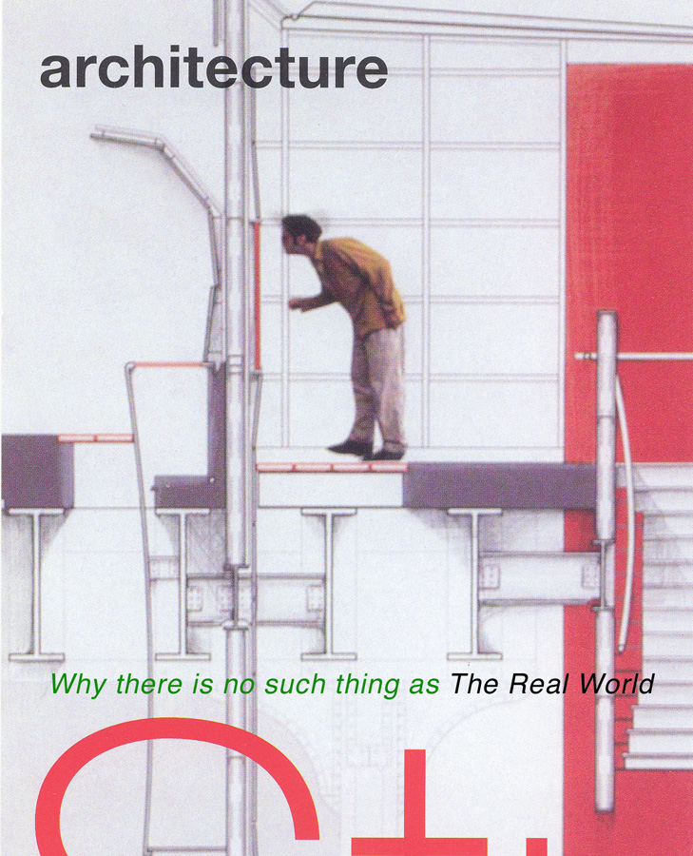

In 1947, Le Corbusier wrote: “I have never been able to accept the instruction of the schools for the simple reason that I have a bad character…”

I was struck by this comment for two reasons. Firstly, because I think that it is precisely that “bad character” that made him a great student of architecture and ultimately a great, albeit unaffiliated, teacher. But, my other thought was how like my own reasons for never joining the AIA. Corb, of course, was thinking of the doctrinaire and conservative practices of the Ecole des Beaux Arts with its self-sustaining and exclusionary claims to the “truth about architecture.” In my case, I have bridled at the AIA’s regulatory claim on the profession and the education of architects. But, as I say, it may only be that I too have a bad character.

So, what exactly did Le Corbusier mean here? I think he was merely suggesting that he did not comfortably sit in groups who appear to spend more time establishing rules and regulations than in discovering the contingent and life-affirming exceptions to rules and regulations. I also know he did not like diplomas with their “ signatures and flattering emblems” and underscored this by declaring: “I know quite well that later on, when the students are thrust into real life, they are forced to acquire a different diploma: that of reality…” While I suspect we all know what Corb was driving at, it does provoke the question: where exactly had the students been if not in “real life?” It is this peculiar rhetorical trope, the real world, which I want to visit tonight.

The notion of a real world has been the shibboleth of the profession in the long-standing and mutually confusing education wars and has conjured a number of the now familiar dichotomies that have come to characterize the combatants: theory vs. practice, knowledge vs. experience, ideality vs. physicality, designing vs. making. But, how useful has this call to the real world been… I mean really. Not very, I think.

This sundering of existence into the real vs. whatever its alternative might be - the false, the inauthentic, the illusionary, the unreal – has only served to sunder the importance and value of teaching & learning while raising up the specter of a retributive professional life. It calls into evaluative question how one should spend their intellectual time and injects a moralizing ethic into that quest for understanding. But let me continue, for the moment, w/ a still remarkably fresh jibe from Corb:

“I admire”, he says, “the dazzling manual skill acquired by the students through their instruction at the Ecole des Beaux-Arts…I recognize the elegance, which guides the solutions of plan, façade, and section. But, I should like to see intelligence dominating elegance and not being disregarded” “Design has killed architecture. Design is what they teach in the schools…the school kills; the school kills by being shut off far from crafts and materials. Reality is lacking.”

Again, Corb’s point is pretty hard to miss but this business of the real world appears once more to remind the students of their poor decision-making in choosing to attend architecture school and to dissuade anyone in their right mind from taking up an interest in teaching at one.

I think Le Corbusier’s reaction against the Ecole des Beaux-Arts was legitimate but I also think he was a bit careless with language in his attack on what he called The Academy. For it is this notion of The Academy that also validates the notion of The Real World. Both are abstractions, misleading generalizations that neatly but reductively bundle up systems of perceived value and set the stage for discursive and unproductive tirades.

It is noteworthy that architecture seems to be the only discipline that I can think of that has so consistently experienced this battle between its academic world and its professional (or so-called real) world. Does this happen in medicine, law, or business? I think not. Teaching architecture has always been problematic because there is the assumption that the object or goal of this education is professional competence in the material design and making of a building and yet, most students spend 3 plus years not even attempting this once. This is unlike other professional disciplines, such as medicine or law, where the professional education provides direct hands-on testing of one’s facility to practice. And it is for this reason that I suggest to students that we do NOT teach them to do architecture but rather teach them to THINK about doing architecture. Later, when they become professionals they will learn how to do it in the true sense.

In my judgment, this is what good schools have always done. Good schools are typically not “conservative” in the sense that they take seriously the fundamental goal of gathering up knowledge in order to facilitate social change. They are, by nature, contentious, experimental, and critically reflective about the world as given. Most significantly, they are future-oriented quite simply because for students, the future is the only possible real world.

In a redemptive turn for me, Corb later begins to distinguish the Academy as social abstraction from teaching as social practice. He says:

“Learning? That is the joy of every day, the ray of sunlight in life” “I would not be hostile to the School if the commentary went thus: Here is what was done; here are the reasons for it. In the present circumstance, such things can no longer be effective. On the other hand, they show, how in all times and places, the spirit created, made new things, and marched forward based on existing contingencies. And so, investigate the contingencies, establish their nature clearly and set your feet on that mobile springboard in order to leap forward. In that way you will do things which are true, useful, and of unquestionable value.”

And so I am suspicious of attempts to professionalize education in architecture. For the profession has little choice but to operate within the constraints of an existing real world. As an alternative, I would hope that professionals, while remaining vigilant in their responsibilities to that world, might better recognize their roles as teachers – to teach their young acolytes what they have learned while remaining open to new possibilities that these same acolytes set before them.

At this point, I’d like to show a few images of a project that some 2nd year graduate students at Parsons recently designed and built over this past spring and summer. It is a proto-type Cor-Ten steel field house for the New York City public school system.

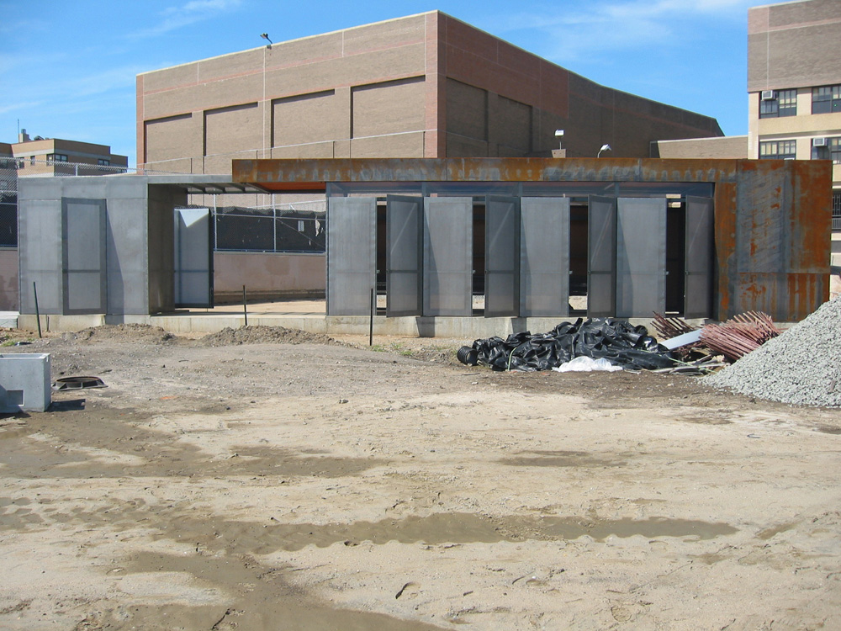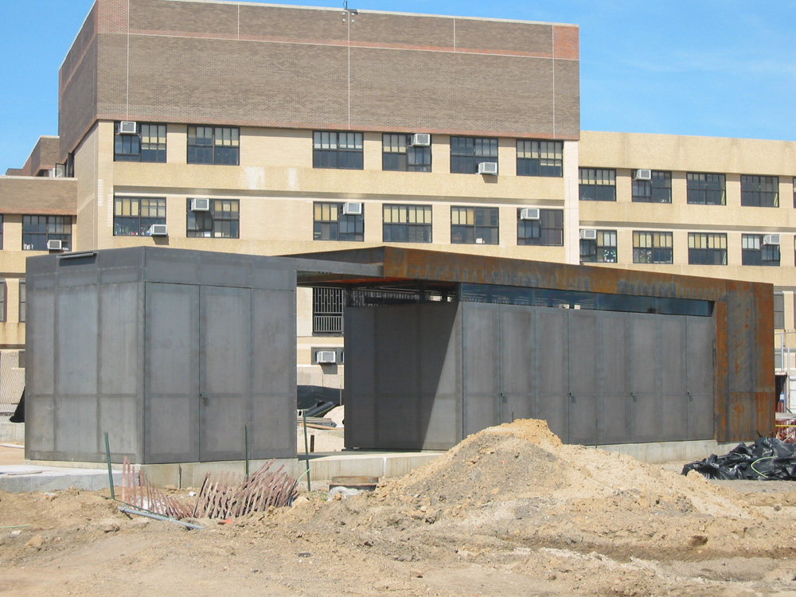

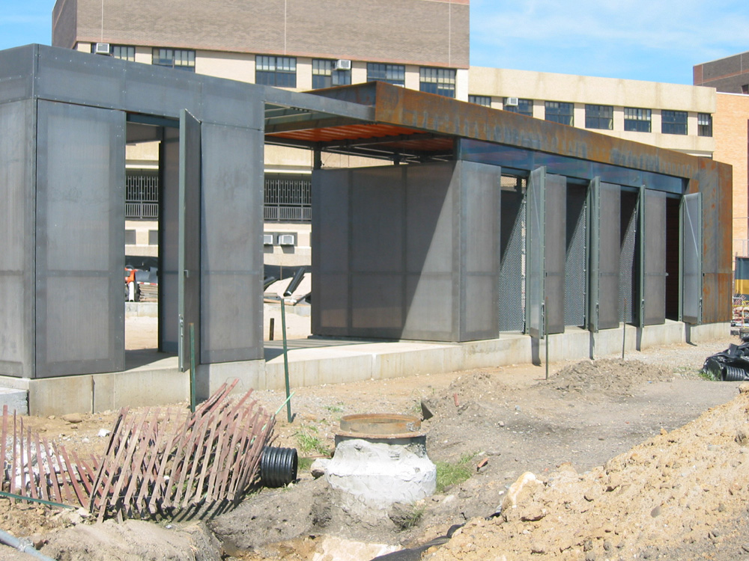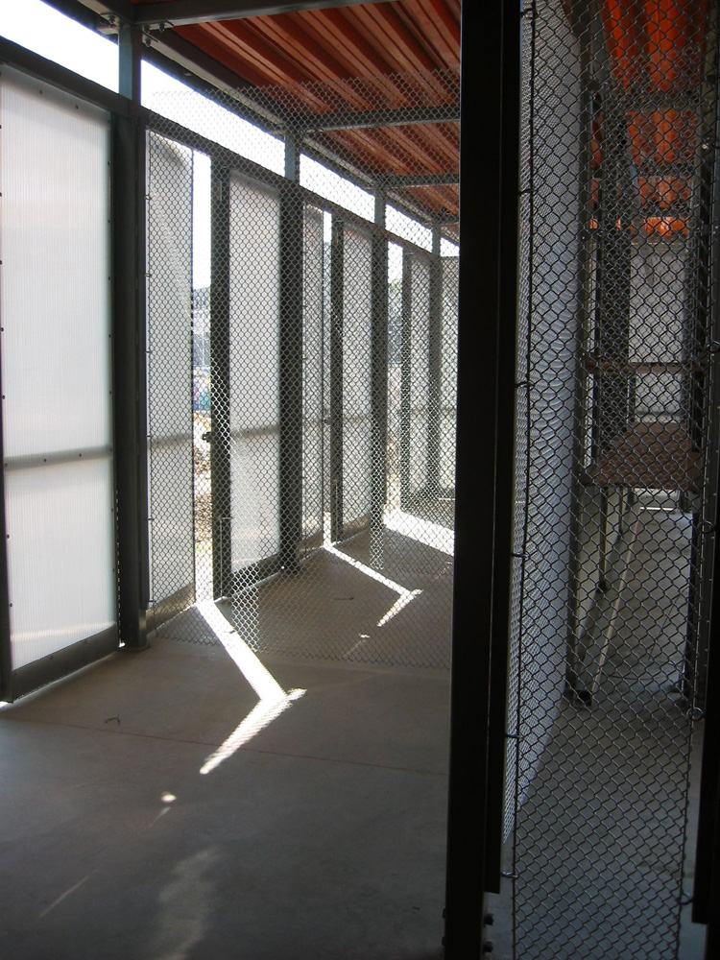

I think these students were lucky to have had this opportunity; they got a taste of what Corb felt was important in his notion of the real world. But, when I see this building, in all of its robust materiality and craft, I do not see it as symbol of the real world at all. I see it, most significantly, as an idea - an idea about people, place, time, and architecture’s capacity to direct light on such things in new and valuable ways.

Toward the end of his book When the Cathedrals Were White, Le Corbusier, after noting his “bad character” demurs and says: “I consider that he who is not conscious of grace does not have the right to be an architect.”

I agree, and I hope the educators and professionals will all learn to be more graceful in their dealings with each other from within whichever real world they find themselves. Thank you

? Le Corbusier, When the Cathedrals Were White (1947 reprint; New York: McGraw Hill, 1964), 208. My italics.
Ibid, 117.
Ibid, 117.
Ibid, 115.
Ibid, 116.
Ibid, 119.
Ibid, 209.

