The Machining of Nature

Introduction: The Mississippi Studio

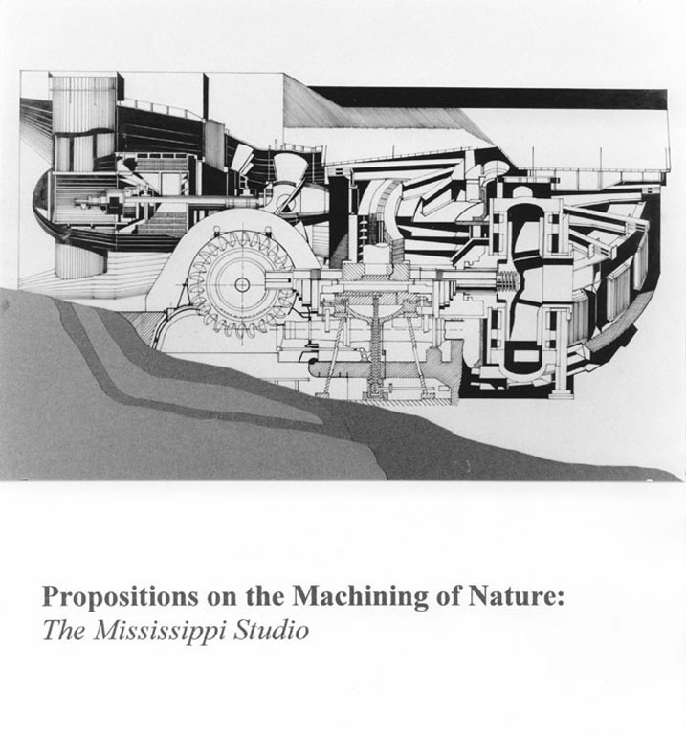
Figure 1. The machining of Nature: schematic mechanical landscape section
(Phase 1 - James Wong)

The following emerged from the thinking and work produced in an under-graduate design studio conducted in the Department of Architecture and Environmental Design at The New School for Social Research/Parson School of Design, New York City during the Fall of 1993. The effects of the receding Flood of '93 were still being measured by a stunned community of riverside dwellers and the engineers empowered to protect them from just such an event.

The Mississippi Studio began with the same question that held the national media's attention throughout the summer: How had it happened that the very mechanisms (dams, levees, etc.) designed to prevent such a flood, ultimately, created the conditions which produced it? During and after the flood, this question generated a great deal of debating and finger-pointing, most of which was directed at the U.S. Army Corps of Engineers. Targeted by environmentalists for having done too much and commercial interests for having done too little, the Corps came under an allied attack from otherwise opposing constituencies, each demanding some form of accountability. Yet, behind the Corps' bashing a more important issue was being raised. Once again, the relationship of our technologies to the landscape was being debated. And once again, the issue centered on whether technology can fix its destructive mistakes (e.g., by building better levees and dams) or whether we are better off leaving nature, as much as possible, alone.

More than any recent natural disaster, the problematic effects of interfering with natural processes seemed clear to everyone and this perception gave a significant boost to proponents of natural restoration. Invoking, with fresh evidence, the claim that the "techno-fix" ideal will always lose in its attempts to control nature and spurred on by a sympathetic ear in the Federal Government, environmental groups argued essentially that the proper response to the Flood of '93 was to stop meddling with the river, retreat as much as possible from its banks and allow its' natural systems to function unimpeded.

While this position provides one form of a solution, it, of course, also raises serious questions in regard to the displacement of commercial and parochial interests. However, a more subtle set of questions rises up from within the environmental perspective itself. How far does one retreat from the edge of the river in an ecosystem which operates at the scale of regions rather than riverbanks? Where does the "natural" river stop and modern civilization start given the 250 years of mutual mediation? How does one balance nature and culture on a philosophical fulcrum which seems to insist on their antagonism in order to provide each term with meaning in cultural discourse. These kinds of questions ultimately became the focus of The Mississippi Studio.

Many of the arguments raised in this text are well known within the environmental movement and the larger academic community. The themes are very much at play in contemporary discourse and have many disciplinary strands ranging from feminist critiques of both nature and technology to the intersection of molecular biology with cybernetic computation. Having been researched within the context of a landscape/architecture design studio, the issues take on a selective and edited focus and so cannot be engaged from the multi-disciplinary level which certainly informs them. Nevertheless, as one means for developing ideas about their application, the design studio is a good incubator and I hope that the following contributes to this process and audience.

2.

Anyone interested in contemporary thought quickly learns the subtle distinctions and arguments which center on the etymological and rhetorical term, "technology." The scope of this project cannot fully address its operational appearances within cultural discourse. Nevertheless, I will make a number of introductory points on my use of the term.

Firstly, while I believe all aspects of technology can be traced back to the human body (either via prosthetic or "organ projection/evolution" theories, the embodied praxis-perception arguments derived from Phenomenology, Lewis Mumford's social and hierarchic "megamachines" or Michel Foucault's analysis of "techno-bio-power"), John Dewey's emphasis on modern technology as an art of controlling Nature in order to assert the practical needs and values of civilization can be argued to encompass rather than differ with these ideas.

Secondly, while it seems evident that the techniques of making mechanical things over and against nature are best understood from an analysis of the particular cultural fields of knowledge that produce them, the earth and humanity are aboriginal and trans-cultural entities whose phenomenological interactivity (i.e., the lived-world) always seems to elude our grasp even as it inspires us to make more things with which to grip it. This fact is particularly noteworthy as we move into a third phase of technology (after pre-modern and modern) distinguished by information and automaton technologies. While the a-spatial/a-temporal aspects of various virtual reality futures seem to some worthy of celebration, it is still difficult to imagine the end of human-produced machines in "real-time space". In point of fact, what is of real significance about this phase of technology is that these machines are best understood in terms of the cybernetic model of biotic ecologies, i.e. Nature. Whether this represents a crippling paradox or the beginnings of a new definition of the lived-world, one can only guess.

Finally, for my purposes, I could have used French civil engineer, Jean Lafitte's term "mechanology" in Reflections on the Science of Machines (1932) since it seems to best cover the everyday use of the word "technology". In this usage, technology is fundamentally about the mechanics of material artifacts and machines produced by and for the use of human beings. However, since machines emerge in complex ways from the technical logics ("techniques") of invention, production and utilization in a given society, I am compelled to maintain the broader term of "technology" to underscore this relationship to culture. This, I feel, also allows me to place more easily The Mississippi Studio within the culture vs. nature debate.

3.

The above being said, I want to insist upon a proprietary right. It is beyond doubt that architecture is inextricably linked to technology and nature at a most profound level. Furthermore, architects and engineers are said to exemplify Homo faber, driven as they are to make extraordinary material fabrications from clumps of nature. On the other hand, Lewis Mumford's description of humanity as "preeminently a mind-making, self-mastering, and self-designing animal" or Jose Ortega y Gasset's extension of the concept of the technological to the "invented life" suggest it is our capacity to first imagine and then make ourselves that not only distinguishes our species but also our destiny.

Ultimately, we know ourselves by the things we make and the spaces we occupy. Yet, these material fabrications are projected from an imagined world, one that humanity has been creatively reinventing since showing up within the biosphere. From this perspective, it seems that architects have always had a responsibility to understand not simply the space of architecture but, more importantly, the space for architecture. After all, it is this latter space- call it, for the moment, what you will, culture or nature - in which they must build.

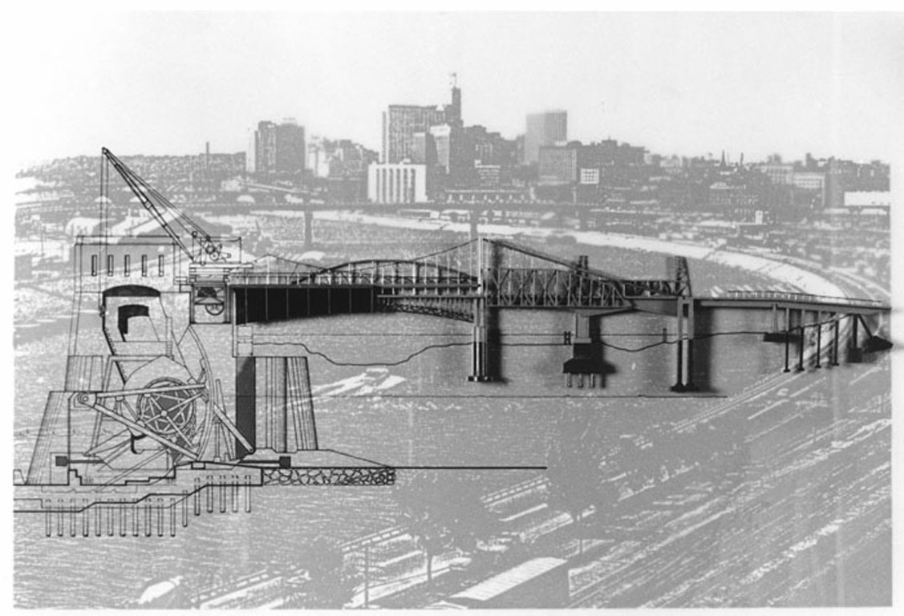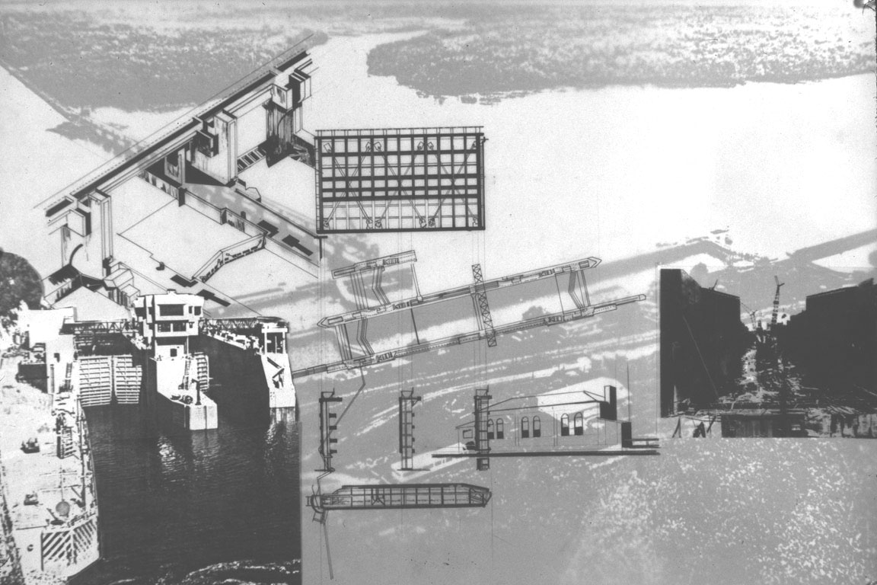

Figure 2. River tectonics: Crossings and Interventions ( Phase 1 - Char Chiba)

4.

When The Mississippi Studio was first proposed, I was asked how I intended to direct the site visit to the river. A legitimate question, it presupposes a convention in architectural theory/practice which requires that a site be "experienced" - the physical/material context understood - prior to any design work. Nevertheless, it was my intention to withhold any visit to the site until 5-6 weeks into the 14 week studio process for two reasons.

Firstly, where would one go? The diversity of landscapes, infrastructures, and cultural configurations from Minnesota to the Gulf of Mexico undermine any unitary comprehension of the river. Its' systemic effects are vast, incorporating in barely discernible ways much of the nation. There simply would be no time in a single semester to absorb such a complex entity.

Secondly, and perhaps more importantly, I had another idea of "context" in mind. While the "site visit" may allow us to see the visible features and even the subtle aspects of a site's community life, it does not necessarily provide insight on how we see these things, i.e., the perceptual/conceptual framework which organizes our experience of the site. Following the lead of a number of contemporary environmental historians, geographers, and philosophers of the environment, I felt it best to first investigate the varied socially-constructed perceptions of the river. Equally complex as its material forms noted above, the river's differing significance gathers within it much of the political and poetic histories of this country. The various representations of the river speak of our literary traditions embracing American ideals of naturalized freedom, individualism, and fronteirism but also of our economic and land policies based on collective consumption and technological expansion and exploitation. Frederick Jackson Turner's view of Twain's Mississippi collides with Secretary of Commerce, Herbert Hoover's Channel Projects and the practice of everyday life in a local riverside agricultural community views a very different river than that of the National Park Service or the Sierra Club. By studying these conflicting representations of the river, each perfectly accurate within its' "context," I hoped to engender a broader understanding of the complex relationship between culture and nature and, in particular, to provide a framework for researching and understanding both the technological and ecological mechanisms of the Mississippi.

Consequently, the first 5-6 weeks of the semester (Phase 1) were spent researching, interpreting, and constructing two scales of phenomena. Large scale settlement, use, and ecological patterns were mapped simultaneously with a "cataloging" of the small scale "instruments" (locks, dams, revetments, constructed preserves, etc.) which configure and sustain these patterns. Whereas the mapping focused on an understanding of the natural environment and its' cultural counterpart, landscape, as a complex manifold of interrelated issues extending beyond immediate locale, the small scale studies attempted to zero in on the architectonics of local conditions - the details and structures of the regulating machines which derive their forms and processes from the natural hydrology of river even as they, in turn, render the river more "mechanistic".

This analytical phase not only provided a description of varied effects along the Mississippi, it also constituted a tectonic vocabulary from which the subsequent individual proposals drew. This latter point is particularly critical in maintaining a connective thread through site analysis and program development to the subsequent generation of tectonic form. Throughout the process, information was shared, debated, and placed within a seminar component consisting of readings on technology, environmental ethics, cultural theory, and social/natural ecology. It was concluded with an exhibition and school wide presentation, providing them an opportunity to synthesize, articulate, and speculate on the river as they had come to understand it (see figure 3).

Whereas the range of each student's initial investigations covered both a wide area of national territory as well as generic conditions of interface between technology and the river, the last portion of the semester (Phase 2) was directed to a specific site anywhere along the length of the river. Each student chose their own site, according to their emerging interests, and developed their own program for that site. It was at this point that individual students first saw the river, fanning out along its 2300 mile length to their chosen locales.

Although the sites chosen had parochial concerns which each student necessarily addressed, what seemed to link all of the projects was an interest in placing the local site into a larger didactic perspective. One which engaged the river as a whole and as an exemplary model of our culture's conflicted response to the biotic and abiotic environment.

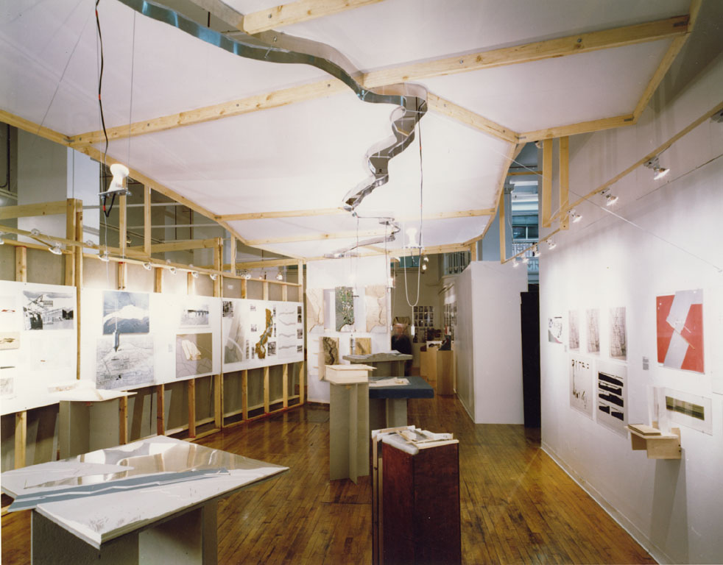

Figure 3. Mississippi Studio Exhibition: projects registered to ceiling-hung model of the river

5.

The following text has three parts: The first section briefly discusses the thorny and intertwined relationship between nature and technology as it has developed in American culture and suggests a re-thinking of this relationship. The second section focuses on the Mississippi River itself as the "site" where the issues discussed in the first section are at play. A portrait of the river is rendered which attempts to convey its' complex and varied formations. Both of these sections are accompanied by the descriptive, analytical, and speculative work of the students during Phase 1 as well as by material from the U.S. Army Corps of Engineers. In the third and final section, selected student proposals are illustrated and discussed.

It should be noted that most of the credit should go to my students. A fabulous bunch, they comprised one of those every 5 year studio configurations that just click. Most of the following text reflects their research, observations and critical faculties. Students of an undergraduate program which does not confer a professional degree in architecture, they were free to traverse a broad range of disciplines tangential to architecture - engineering technology, ecology, hydrology, landscape, environmental ethics, etc. - to inform their design work. In both their methods of representation and their thinking this ecumenical approach served them well.

Finally, I should express my appreciation to John Anfinson, Historian for the USACOE in St. Paul, Mn. who probably braced himself for another Corps bashing but ended up as a thoughtful fact checker and lively critic.

Life on The Mississippi Redux

The military engineers have taken upon their shoulders the job of making the Mississippi over again - a job transcended in size by only the original job of creating it.

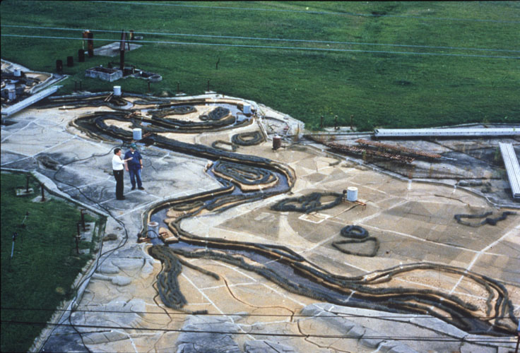

Figure 4. The USACOE Waterways Experiment Station, Clinton, MS: scale model of the river.

In a remarkable attempt to meld, once and for all, the biosphere to the mechanosphere, the United States government has recently embarked on an ambitious program to fully "technologize" the Mississippi River. Under the auspices of the United States Army Corps of Engineers, information from satellites tracking national weather patterns is dispersed throughout a network of control sites along the River and its tributaries. Reservoir dams, flood gates, navigation locks automatically respond to the information flowing into remote computers. Tainter gates swing, roller gates drop, shear gates slide, pumps surge and the flow of water which drains nearly half of the continental U.S. becomes regulated according to a digitalized extraterrestrial rendering of the river and the impending rain that constitutes and regenerates it - the very profile and texture of the "natural" river, its height, course, and speed modeled on a virtual river.

It would appear unfortunate for many riverside residents of Minnesota, Wisconsin, Iowa, Illinois, and Missouri that this idealized system was not fully in place during the summer of 1993. That summer, after a winter of heavy snowfall and a wet spring, torrents of rain fell upon a saturated and swollen ground no longer capable of absorbing it. Shunted off the surface of the earth, the water converged on the already high swells of the Mississippi River and its tributaries to create the most damaging flood in modern U.S. history. However, were the negative effects of that much rain avoidable? And, if so, would the government sanctioned strategy of the USACOE have made the difference that summer?

If natural history is any indicator, it is more likely that something will happen to make the Corps' cyberspatial project, as presently conceived, obsolete before it is finished - or shortly thereafter. This seems to be what typically happens when instrumental technology pits itself over and against "nature." In fact, often, consequences are more serious than simple obsolescence. While the Flood of 1993 was in full swing on the Mississippi, a predominant concern was whether the protective levees and dams, engineered on the model of another virtual reality - the USACOE's hypothetical 500 year deluge - were making things worse.

Yet, it is too simplistic to disparage the Corps of Engineers; they only facilitate a process that is deeply ingrained in the cultural history of this country. With regard to their authorized responsibility to maintain the waterways and coastlines of the United States, one could as easily invoke their successes as their failures. The more urgent issue lies in a way of looking at the world that we all share to greater or lesser extent.

How is it that, time and again, we seem to find that our technology, while ostensibly driving us progressively forward, circles back to rear-end us? But, more importantly, why does this always, without fail, catch us by surprise? While the first question lurks like a mechanical glitch within a metaphysic built on beliefs in science and progress, the second question attempts to assert itself from outside of the very philosophical system that ponders it.

It is more than the unpredictability of technology's effects and consequences that is problematic here. It is precisely because we are so heavily invested in the idea of its' predictability in the first place that makes its failures so hard to accept. As Culture's primary means of attempting to make predictability (as a critical component in relations of control) possible in the face of an unpredictable Nature, technology's success is measured by its capacity to produce a definitive and calculated presence against which natural processes will turn away. But Nature does not turn. The preeminent Shape Shifter, it simply recasts itself unexpectedly to conform to and appropriate the profile of technology's underbelly.

This peculiar dynamic is played out in many ways and places where the mechanisms of technology, operating in the name of culture, have converged with those of "nature." Yet, it operates below the threshold of visibility because it does not conform to what most of us have been taught to see.

Nature as Natural Kind

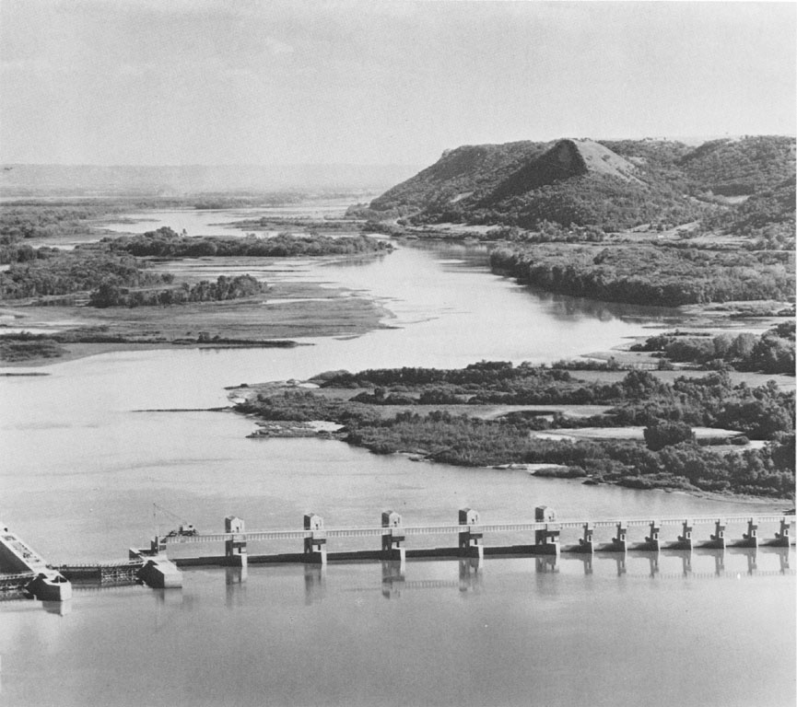

Figure 5. Technologized Nature: "Pool 6" Trempleau, Wisconsin. In USACOE jargon, the river water between each dam is referred to as a pool. The "mechanical" constraints on the water "naturally" reform the adjacent landscape.

Despite contributions by philosophers of modernism such as Heidegger and Foucault
who - while sounding the alarm of modernism's dangerous instrumentalism - see technology as a practice as old and as "natural" as humankind itself, most of us (and certainly many of those who have dictated the political topography of environmentalism's terrain) continue to see Nature and Technology as the incompatible poles about which orbits the fate of the earth. In this view, Technology is linked to a conception of the Industrial Age as the advent of a process of mechanization which has increasingly gone amok within a blameless and, essentially, defenseless Nature. Yet, this view also maintains a description of Nature, which unwittingly contributes to the very forces of technology it is supposed to withstand.

On the Technology/Nature fulcrum, Nature is objectified, placed apart from human subjects as if it were a stage set, an a priori space into which humanity has been placed to act itself out. While most of us understand the primordial chemistry and dynamic surface of the earth as preexisting humanity, fewer understand that the introduction of the descriptive term Nature into humanity's lexicon represents a value laden and ever changing attempt to describe this all encompassing biosphere and, in so doing, to locate ourselves within it. Since we are exclusively bound and cannot exist apart from the surface of the earth (unless we take a part of it with us in the form of rocket technology), the act of spatializing the earth by describing it is a basic necessity if we want to have any chance of describing ourselves.

While certain cultures have maintained fairly constant descriptions of Nature, western metaphysics, with its inherent "need to know" epitomized by Enlightenment science and social theory, has produced a range of varying combinations describing the relationship of humanity to the earth. In particular, in this country, three linked conceptions of nature have operated most forcefully and are, not surprisingly, situated historically within its' formative moments. One arrives with Puritan theology, another with the political theories of early capitalism and democracy, and, lastly, with the poetics of a unique and enduring literary tradition.

In the first case, the 17th century Calvinist pilgrims, laden with the harsh biblical imagery of the "savage wilderness," found their expectations well met. "Unsettled" and unsettling, Nature in its raw wild form represented a challenge to overcome, an enemy to defeat. Sanctioned by Old and New Testament alike, the "taming" of the wilderness was not only necessary for survival, it was sacred work. Today, this reverence has seemingly reversed. The relentless texture of civilization has become "savage" and "wilderness" treks antidotal. Yet, how has it happened that in political discourse and popular rhetoric, we privilege the natural over the technological while, in practice, continuously call upon technology to reconstruct the body of nature? This contradictory behavior is forged perhaps from the second conception of Nature.

In this view, the wilderness is mastered and the business of mere survival gives way to more creative modes of production. Nature softens. The Lockean/Utilitarian vision of land as a natural (God-given) commodity to be owned and developed defines, perhaps, the moment when Nature is first rendered passive, replete with the potential for serving human ends - a genderized, pregnant Mother Nature. The humanizing of nature meets the naturalizing of humans in the concept of mankind's "natural" rights of Property and the landscape begins to be "plotted" with the purpose of not only delimiting ownership but also of mapping strategies for development. This cozy relationship with Nature while on the one hand setting in motion an instrumentalist perspective (how to best utilize the land to accommodate culture) also allows a non-conflicting way to talk about the Environment three centuries later. In the early 20th century, President Roosevelt's Conservation movement, while recognizing the importance of this country's natural resources, argued that the landscape should be conserved not for its own sake but to yield its' maximum benefit to humanity. Although the Common Good begins to override the natural rights of individuals, the idea of Nature exclusively in the service of humanity remains.

In the contentious nexus of the environmental debate, this conception of Nature (through a reinterpretation of its utility) collides with the third model often associated with the founder of the Sierra Club, John Muir. While there is agreement in these models on the sanctity of Nature, there is profound disagreement about humanity's relationship to it. Credited with initiating Roosevelt's Conservation Movement, Muir's ideas are actually more closely linked with the Preservationist point of view inspired by the idealism of the New England Transcendentalists. In Emerson and Thoreau's literary vision of an artificial and corrupting civitas, Nature is presented as authentic, the "city of God." As the source of moral and spiritual enlightenment, Nature becomes the gateway to a "transcendent" reality wherein scientific method and its technological offspring are revealed as seductive but, ultimately, lesser cultural artifice. In this view, Nature is a significant entity in its own right, elevated beyond any humanist perspective. Although in modern times the mystification of Nature has receded, this romantic view remains in any contemporary discussion about Nature's fate.

While it is not difficult to see how the first two conceptions of Nature might engender a full scale technological response - either to accommodate and protect expansionist Culture in the first case or simply to satisfy the voracious appetite of Capital in the latter - it is often overlooked how this third model of Nature has, inadvertently, helped to construct Technology's present identity in the very process of cleaving it, so thoroughly, from Nature itself.

The romantic view of Nature which projects a timeless and virginal beauty is problematic at many levels. Besides contributing to the master-full language of genderization mentioned above, it tends to ignore both actual ecological processes (earthquakes, lightening fires and other forms of "natural disturbances" whose effects can be as horrifying for humankind as "technological disturbances.") and the constant, and often formative, pre-European (native) presence within this country's "wilderness." Yet, it is the ideality which places something "out there" and thereby distances us from it that is of most concern.

Commenting on this pre-Darwinian picture of humankind as separate from Nature, Joseph Des Jardins has noted,

from this perspective, acceptance of a dualism ("man and nature") only encourages moral hierarchies ("man over nature") and conflict ("man against nature")

Even when one extends this comment to the benign humanism of recent environmentalist discourse (e.g., "man's stewardship over the earth"), the metaphors of domination continue to lurk. And it is this underlying anthropocentrism that differentiates itself from the natural that seems to set the stage for a similar confusion regarding Technology.
Ex Machina

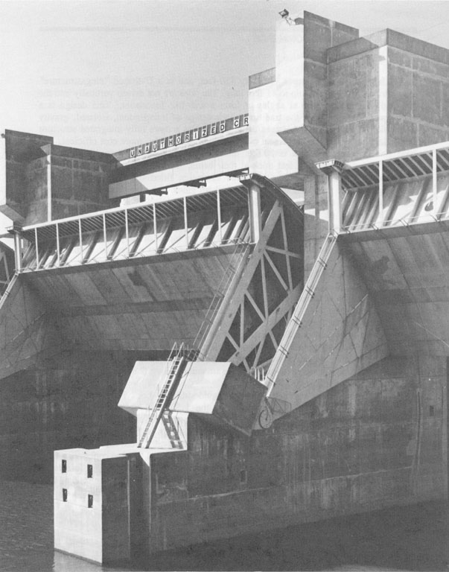

Figure 6. Lock and Dam 26 R

In a concise and telescopic triptych of humankind's top three humiliations, Richard Rorty cites Copernicus' representation of ourselves displaced within the heavens, Darwin's representation of ourselves as "selected" and specieated, and Freud's representation of ourselves as non-self-transparent individuals. As Rorty notes, this unsettling triangulation seems to converge less on our loss of significance than on the alarming conception of a mechanistic universe in which Aristotelian notions of humanity's "essence" and "purpose" are rendered obsolete. It is a universe which looks "like a rather simple boring machine, rambling off beyond the horizon, rather than like a bounded and well-composed tableau." Yet, although often kicking and screaming as our telos fades from view, we are not - by nature, if you will - shirkers. If it is to be mechanics...then bring on the pendulums, fulcrums, and rolling steel balls. Physics, itself, will straighten things out for us.

While western conceptions of Nature are rooted in a telos driven by Judeo-Christian theology, Technology, in its modern form, is typically linked to the apotheosis of modern science - an ordination which took place once the scientists became more persuasive than the priests in explaining the picture of the universe. As the metaphysics of a theological and ineffable cosmos subside and the Newtonian forms of a mechanical and material universe emerge, modern science is born and becomes the authoritative source for revealing Nature. At the same time, the Cartesian reductio sets the standard for sciences' revelations and, of all the sciences, physics, with its seemingly flawless capacity to reduce complex phenomena to simple non-qualitative objects, stands as the most authoritative. Even as we acknowledge that in some inscrutable (nescient) way, the whole is greater than the sum of the parts, our goal continues to be to ferret out as many parts as possible; and the smaller the better. In order to best "know" them, the processes and objects of Nature are shaken apart into the distilled chemistry and formulaic links that constitute all physical phenomena.

Yet, while scratching humankind's itch for natural dominion, physics not only operates in the knowledge-gathering realm but also in the instrumental realm by forging an alliance with technology. The development of this curiously circular relationship between modern physics and technology has been discussed by philosophers of science since Husserl's Crisis of the European Sciences and is the basis for Heidegger's asking The Question Concerning Technology:

It is said that modern technology is something incomparably different from all earlier technologies because it is based on modern physics as an exact science. Meanwhile we have come to understand more clearly that the reverse holds true as well: Modern physics, as experimental, is dependent upon technical apparatus and upon progress in the building of apparatus. The establishing of this mutual relationship between technology and physics is correct...The decisive question remains: Of what essence is modern technology that it happens to think of putting exact science to use?

Indeed, this question has spawned an entirely new philosophical field which is reconsidering the science-technology relationship. Rejecting the conventional assumption that technology is applied science in favor of the idea that science is theoretical technology, a philosophy of technology maintains that technology precedes science in the forms of human actions which have consistently attempted to mediate Nature. It is only our modern penchant for reflecting on our works and workings - whose original value lay in the dynamics of practical problem solving - that, subsequently, turns them into "objects of knowledge" with scientifically described cognitive status.

It is this latter identification of technology with scientific knowledge rather than with the concrete actions of "natural practices" emerging from our everyday relationship to the earth which often makes it so difficult for humanity to identify itself with its own creations. Stunned by the effects, both positive and negative, produced by the privileged domain of those who can speak in the complex language of technological science, most of us stand as dazzled and awestruck by the "magic" of our technologies on the face of Nature as our ancestors were by the "magic" of shamans. Nevertheless, in arguing for a re-thinking of technological practice, the Heideggerean perspective provides a further clue regarding its relationship to the natural realm by suggesting that it is humanity's mediatory technological actions which actually "produce" nature.

Any work with which one concerns oneself is ready-to-hand not only in the domestic world of the workshop but also in the public world. Along with the public world, the environing Nature is discovered and is accessible to everyone. In roads, streets, bridges, buildings, our concern discovers Nature as having some definite direction...

Remarking on this way of understanding Nature through our actions (technology) rather than through our knowledge (science) or transcendental idealism ("thing-in-itself"), Don Ihde suggests

...the technological context implies a certain "view" of nature. The technological context is, anticipatorily, a certain possible way of "seeing."

What is so intriguing about this argument, which inextricably links nature and technology, is the assertion that it is impossible to know one without the other. It is an argument, as well, that recasts their conventionally presumed antagonism from the draconian image of alien entities excoriating one another in incommensurable tongues to that of a simple but serious domestic dispute. It is, ultimately, telling that in contemporary nature versus technology polemics we find it most easy to argue the values of one by invoking the shortcomings of the other. This form of argument-by-negativity underscores our inability to coherently separate and present them on their own terms even as we maintain their status as oppositional paradigms. For some peculiar reason, their existential affinity in the modern world is too close for comfort and, while one can only speculate on this, it may be that our greatest fear is not the loss of nature or the restriction of technology. Rather, it may be the inconceivable but intuited sense that they may somehow collapse into one another that is at the heart of our discomfort. Like any major paradigm shift, this change in worldview could only be unsettling.

The Tectonics of Nature

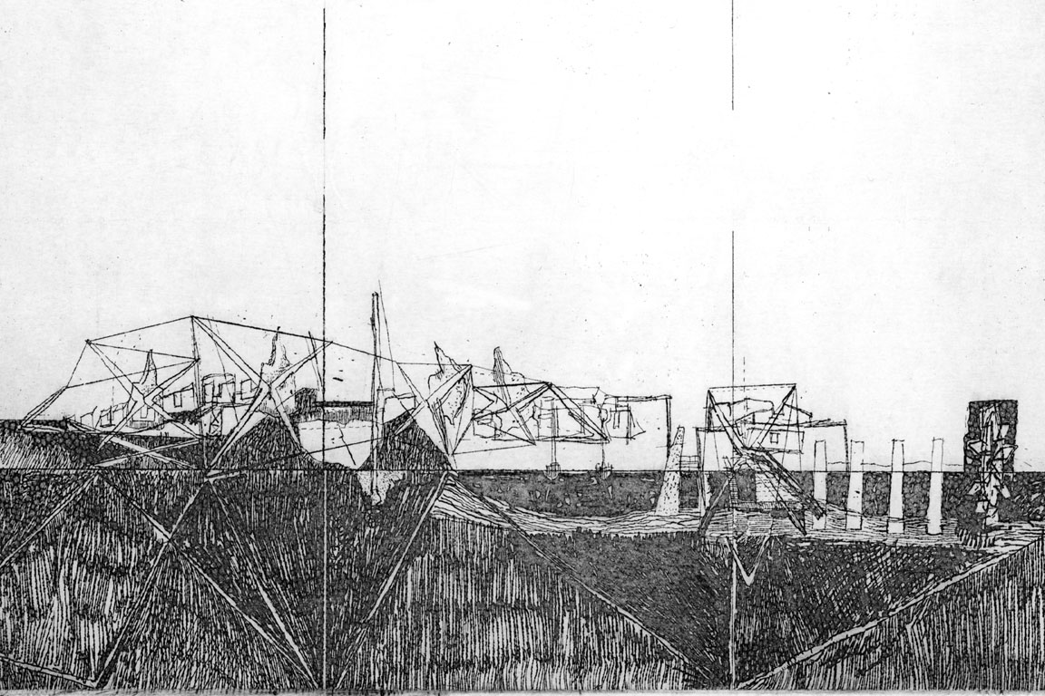

Figure 7. Epigenetic Landscape, Spokane, La. (Phase 2 - Ali Koluman see figures 28,29,30)

At the end of the 20th century, the natural world is getting yet another look. The privileged place of physics as the science which best describes the world is being challenged from within the scientific community itself. In an appealing and ironic twist, the environmental movement, with all of its well-intentioned flaws, has created a focus on the dynamics of bioscience. The increasing acceptance of a description of Nature as an interwoven and reductively indeterminate network of ecological systems has begun to loosen our tenacious and teleological grip on the conception of Nature as generated by or convergent upon "a single common denominator."
This relational activity which makes it difficult to talk meaningfully about single entities without including the "totality of involvements" favored by Heidegger's ontology, can be seen in the cybernetics which range from the scale of genetic biology to global biocenosis and beyond. The point is made by J. Baird Callicott that:

...The ontological primacy of objects and the ontological subordination of relationships in classical western science is, in fact, reversed in ecology...Ecological relationships determine the nature of organisms rather than the other way around...The whole, the system itself, thus, literally and quite straightforwardly shapes and forms its component parts.

Even within the pro-technology perspective, there is a marked shift from the celebration of material artifacts and machines to a celebration of flows and fields. The Electronic age, typically understood as the technologically evolved version of the Industrial age, speaks in the language of networks, webs, energetics, informational interactivity and "virtual" objectivity. This switch in language is certainly facilitated by a switch in language within physics in the twentieth century from particle to wave to quantum mechanics, but it has been the concomitant philosophical conundrum of the immateriality of sub-atomic objects - immaterial because they do not behave like any physical object and are not physically observable - which helps direct the ears of the scientific community to the modalities of ecological discourse.

However, the radicality of systemic or cybernetic thinking is most clearly seen when directed to a consideration of tectonics and the making of technological form in the space of nature. Architecture and civil engineering operate in the nature-transforming space of technology either in their aspect of habitable artifacts or in the details of mediatory (controlling) mechanisms. If one questions the geometrics of architectural/engineering tectonics as founded upon a neo-platonic vocabulary of autonomous, idealized formal objects and posits instead an ecological morphology in which, as ecologist Paul Shephard suggests "objects are temporary formations... within complex flow patterns", it seems possible to imagine a way of relating these practices (architecture and engineering) back to nature in newly considered ways. Remarking on a similar mode of configuring formal objects via energetics, Paul Virilio states

This helps to clarify not only the crisis of "whole" dimensions, but specifically, the ways in which our habitual notions of surface, of limit and separation have decayed and given way to those of interface, commutation, intermittence and interruption...In this irruption, the geometric dimensions become, for the planners, nothing more than momentary surface effects ...

Although Virilio is arguing from the technological model of computer informatics - what he terms the "dromosphere" - rather than that of biotic ecology, both share notions of process preceding substance and energy as more fundamental than matter.

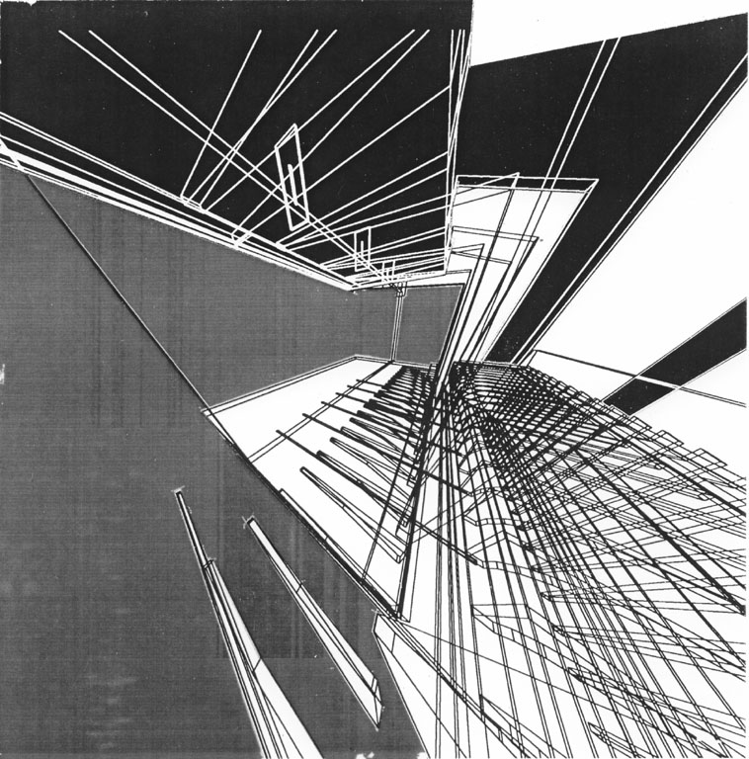

Figure 8. Systemic Field: Artifact & Hydrological interactivity: computer model of water flow levels & structural/programmatic impedance within the building, Cairo Civic Center, (Phase 2 -Christiano Bottino-see figs. 31,32,33)

In arguing directly for the biological model as critical to any discussion of tectonic form, Sanford Kwinter makes a similar suggestion to Virilio's and Shephard's:

What is central here is the dynamical theory of morphogenesis, which characterizes all form as the irruption of a discontinuity, not on the system but in or of it...All the forms of the universe are produced as byproducts or maps of particular evolutionary segments of one or another dynamical system. Indeed, forms are not fixed things, but continuous metastable "events"

Ultimately, the inversion implied by this idea of systemically-constructed objects - as opposed to objects with "given" essences that when formulaically combined constitute dynamic systems - provides a useful model for reconsidering the Nature and Technology "objects." It is a way of thinking that helps restore the sense of their mutual embeddedness and a larger ecology wherein the usual culture/nature distinctions do not operate. And while it is a way of thinking that might seem counter-intuitive; if one considers the argument that even our intuition - typically aligned w/ the natural - is culturally constructed, then perhaps it is worth pursuing further.
The River

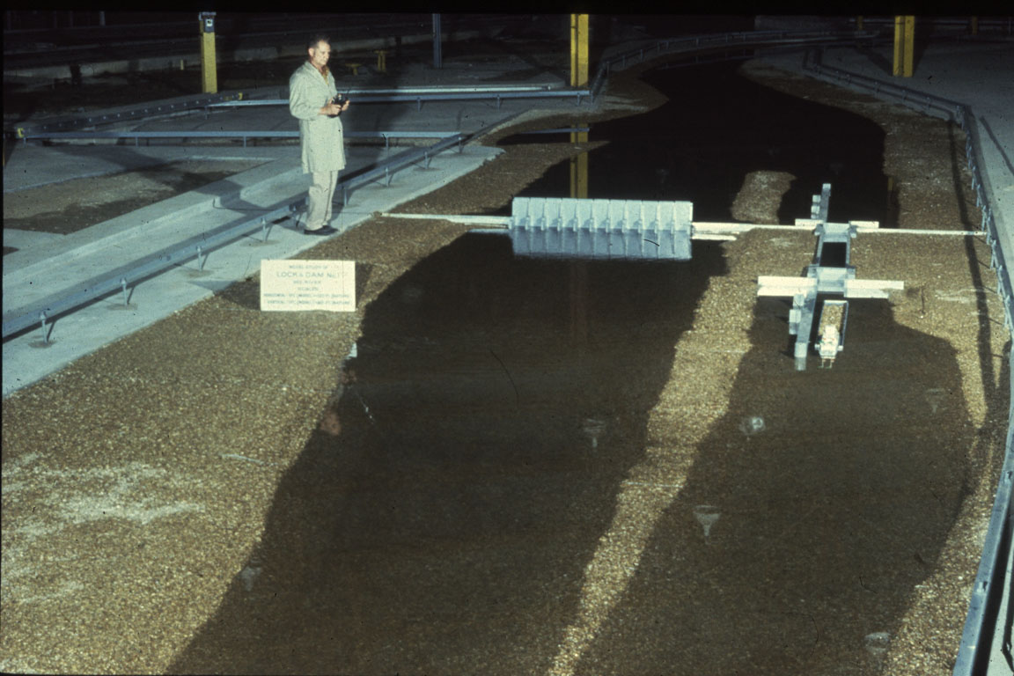

Figure 9. Model study Lock & Dam #1, Waterways Experiment Station,USACOE

In a discussion of Catastrophe theory and its usefulness as a way of understanding dynamic processes and the interrelatedness of diverse systems (rather than objects), Sanford Kwinter goes on to note that

...Forms represent nothing absolute, but rather structurally stable moments within a system's evolution; yet, their emergence (their genesis) derives from the crossing of a qualitative threshold that is, paradoxically, a moment of structural instability.

As an original site and subsequent effect of this interaction for much of modern U.S. history, the "stabilizing" of the Mississippi River has been an enduring national project. Either in the name of expansion, commerce, or more recently, the environment, an extraordinary array of mechanisms have been brought to bear on the river to achieve some predictable form of regulation. Yet, as they strive to maintain control of the river, these mechanisms necessarily transform the land/waterscape causing the latter to reform in unexpected ways; then, in response, new machines/devices are molded from this very reformation to control the new effects. It is a process where cause and effect blur and which is best described as a formless network of relations constantly rearranging themselves within a cycle of "natural" problems ostensibly solved but, actually, only reconfigured.

Yet, there is another effect created by these forms on the body of the River. It is an effect that has made it increasingly difficult to talk about the "natural" river. In conventional thinking, it is assumed that the river always remains available, buried perhaps under the various antagonistic grafts that culture has stitched on to it but nevertheless still discernible and accessible. But is this the case? And if this is not the case, how can we talk of protecting it from the ravages of instrumental technology, much less restoring it? What is the "natural" Mississippi River?

Over the River

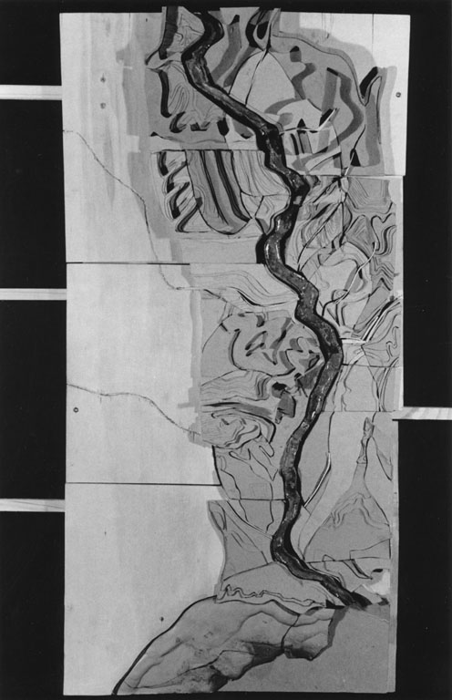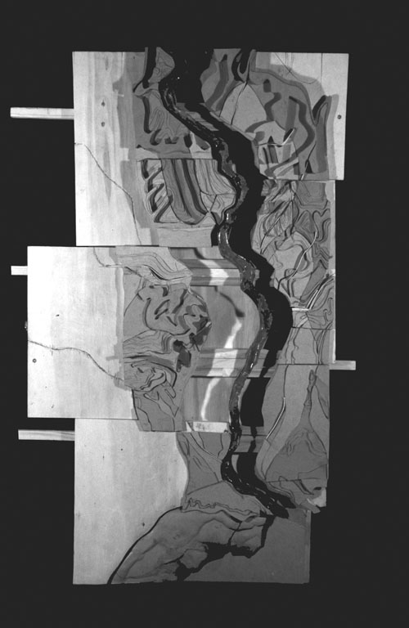

Figure 10a/b. Geologic/Biotic Map 1: "slide rule" map reveals the isolated figure of the river as well as the sectional figure of the geological /biotic formations. (Phase 1 - Letitia Tormay)

2,350 miles in length and dropping 1500 feet in elevation, the Mississippi River runs from Lake Itasca in Minnesota to Head of Passes in Louisiana before spilling into the Gulf of Mexico. Draining 40% of the continental Unites States, it is fed by tributaries from 31 states from Montana to New York.

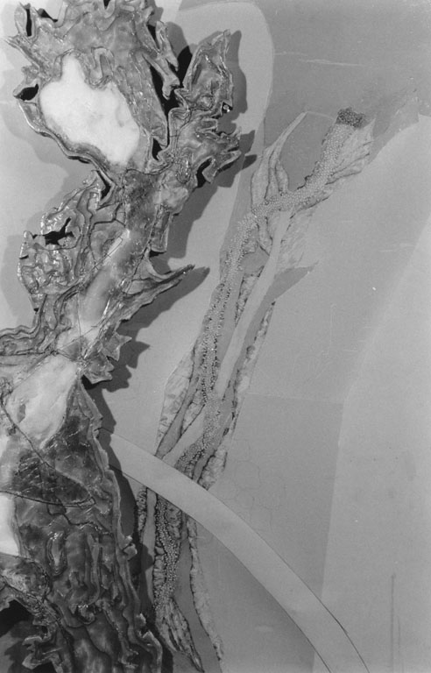

Figure 11. Lake Itasca, MN.: Considered the source of the Mississippi largely due to its high elevation in Minnesota's lake country, Lake Itasca itself is fed by a labyrinth of marshes, swamps, subsurface streams and other underground seepage. A new representation of the source is proposed that does not describe a "location" but rather a "field" of interactive hydrological and geological formations which contribute to the "source" of the Mississippi. (Phase 1 - Letitia Tormay)

Monitored for more than a century by the US Army Corps of Engineers (USACOE), the river is conceived as two rivers. North of Cairo Illinois, the western tributaries predominate. In its pre-colonial form, the northern river was shallow, rocky and flanked by bluffs. South of Cairo, the Ohio River delivers the bulk of the eastern tributaries and the Mississippi enters a wide low valley that was once an embayment of the Gulf of Mexico. Over the centuries, sediment has filled this area extending the river's meandering 1800 miles downstream to its present mouth in the Louisiana Delta. Woven together by an economic system that relies on the river to transport the nation's commodities, natural resources, and industrial production, The Upper and Lower Mississippi annually handles over 8,000 towboats, a bulk load equivalent to 24,000 miles of railway cars. Petrochemicals from the south, grains from the mid-land, and lumber and beef from the north pass one another on the river on their ways to national and international transfer points for overland shipping to the east and west.

The adjoining landscapes vary over the river's length - the waterfalls, rapids, and confluences of Minnesota's rivers, prairie drop-offs in Iowa, marshy drainages within the wildlife preserves of Illinois, the endless levees of Missouri and Arkansas, the wooded bluffs of Natchez, the dense fabric of commerce between Baton Rouge and New Orleans, culminating in the ever-changing delta at Head of Passes, Louisiana. But to call these landscapes "natural" would be to obscure the sight/site of another process.

Over the last hundred years, the tremendous technological effort that has been exerted to bring the Mississippi into conformance with the requirements of civilized culture has virtually recreated it. The dredging, cutoffs, rerouting, etc. have, of course, changed its original topography and space yet the material body of the river itself has been reconstituted as well. Like prosthetic supplements, various devices (dams, locks, revetments, levees, spillways, floodways, freshwater diversion structures, bridges, etc.) engineered by the USACOE have been appended to or inserted within the late 19th century Mississippi River to make it useful. The resulting entity while still known as the Mississippi River bears slight resemblance to its "original" namesake. This new river is a complex matrix of land, water and mechanistic constructions in which what is "natural" and what is "constructed" have become increasingly difficult to discern.

On the River

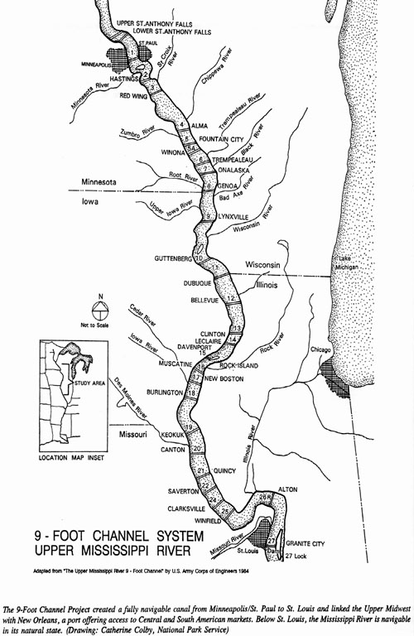

Figure 12. 9-Foot Channel System, Upper Mississippi River, USACOE

Wing and closing dams are the traditional mechanisms engineered to direct the river current away from the shallows. In order to make commercial navigation possible, river flow is deflected by these dams creating an open (non-obstructed) channel. Alluvial sediment within the water is deposited behind and in front of the dams creating new land formations in the backwaters and constricting the river. The river flows faster and more directly but also becomes more susceptible to meanders and floods.

Along the Upper Mississippi, wing dams are not sufficient. From St. Paul, Minnesota to St. Louis, Missouri, the river, in its unaffected state, is too shallow during summer months for useful navigation. To address this problem, the 9-Foot Channel Project was conceived, constructed and is presently maintained by the US Army Corps of Engineers. Since the early 1900s, twenty-nine integrated locks and dams have been constructed turning over 1500 miles of river into a series of water steps down to Alton, Illinois. In conjunction with a system of reservoir dams built within the Mississippi's tributaries, these navigation dams effectively increase the river volume and carefully control its flow to guarantee year round commercial navigation.

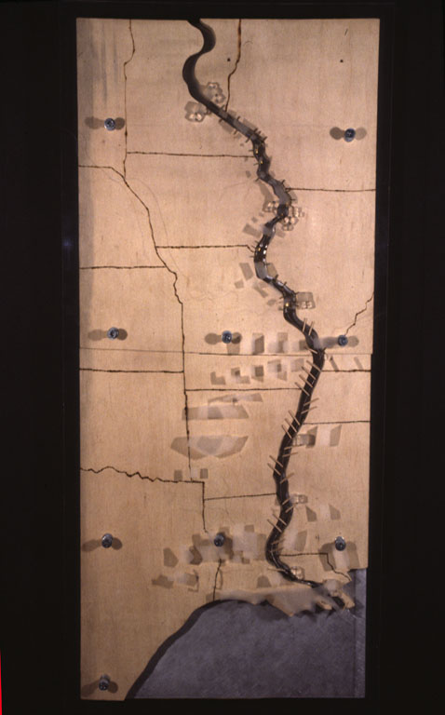

Figure 13. Mechanical Stitches/Constructing the Seam- Map 2: located locks and dams as well as constructed "nature" preserves and urban centers. (Phase 1 - Christiano Bottino, Leyden Lewis, Beth Pappas)

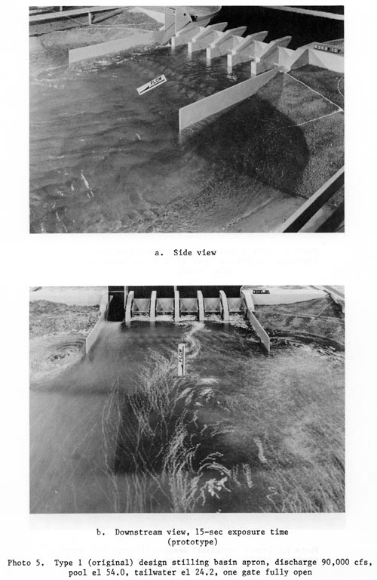

Figure 14. Naturalizing Technology: Hydrological Modeling Apparatus, 1" = 40', USACOE

The 9-foot Channel project has had two major effects on the hydrology of the river. On the Upper river, the increased flow moves slower creating "navigation pools." This transformation of the river's system alters the local ecology. In response to public outcry, a series of wildlife refuges have been established alongside the pools to "restore" the natural balance and demonstrate the possibility of nature's coexistence with a cultural economy. In an odd coupling outside of Alton, Illinois, a several hundred-acre "Environmental Demonstration Center" has been constructed within the Melvyn Price Lock and Dam Project itself. Yet, these refuges and other backwater areas created by these pools are now threatened by sediment from agricultural and commercial foresting. The languid movement of the river is incapable of flushing the runoff and, consequently, it has begun to silt in and reconfigure peripheral habitats. The problems of pollution not withstanding, it is the destruction of these habitats that has environmentalists most concerned.

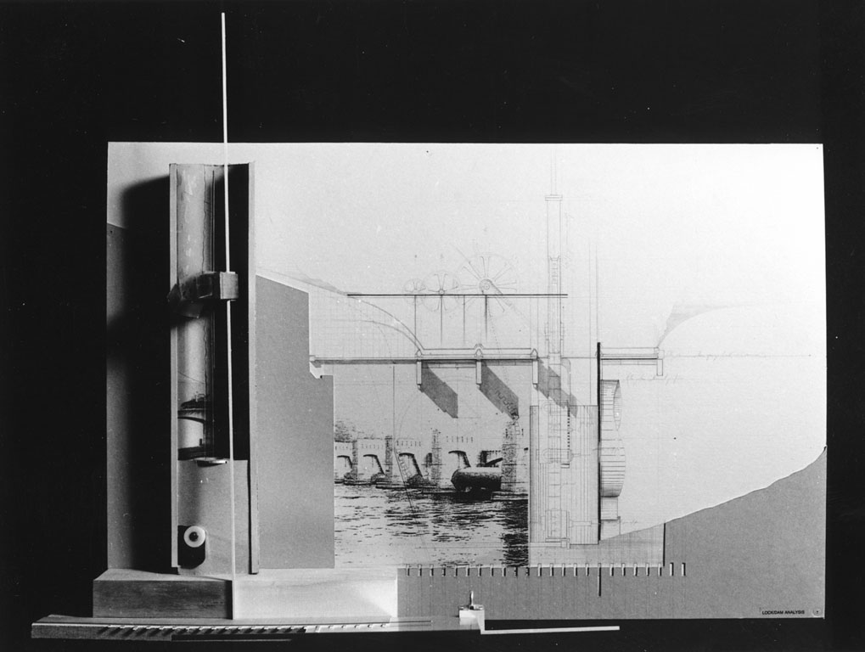

Figure 15. Dam Study- water, land, artifact (Phase 1 - Christiano Bottino)

On the lower river where the increased water volume runs without restriction along a faster flow line, effects are different. More and more silt is carried along this path causing increased river bottom sedimentation within the new channel. The river must be dredged. Dredge boats outfitted with cutter and vacuum heads reconstitute the flanking landscape by excavating river bottom sediment and pumping it to the shallows and riverbanks. Deeper below water, higher above, the channel's volume increases; again, the river flows faster and pressure builds within the system. Virtually every day of the year, a dredge boat is at work somewhere on the Lower Mississippi.

With its flow increased, the river becomes more navigable; however, it's natural meandering becomes problematic - the turns and cutbacks cause obstructions and hazardous currents while the riverbanks become increasingly susceptible to undercutting and erosion caused by the "crossovers" of surging water around the river bends. In the past 100 years there have been over 30 intentional "cutoffs" performed on the river, straightening and further accelerating its course while reducing its travel distance by hundreds of miles. Ox-bow lakes line the Lower Mississippi, isolated traces of the old river's course.

River meanders and accidental cutoffs have historically invaded private as well as political property. The state lines originally drawn according to the old river's course have tried to hold their ground while the river itself has shifted. A number of states now have territory on opposite banks. In the early 1800s the citizens of Missouri and Illinois fought over the river's course and the economic yield it carries when it began to meander away from St. Louis (a conflict won by Missouri through the efforts of a young USACOE lieutenant named Robert E. Lee who devised a means of keeping the river on course).

A more recent method of controlling river meanders and unintentional cutoffs is the embankment project of the Lower Mississippi. In order to resist the river's attempts to break through them, the riverbanks are graded from well below water line back into the landscape at an angle of no more than 22 degrees and then covered with continuous gridded mats of cast concrete concealed beneath crushed rock. A complex system of casting fields, supply, spar, and mat-laying barges has been deployed along the river to produce and install these revetments. More than two-thirds of the Lower Mississippi is artificial shoreline made to appear natural. Except during severe floods, the river now remains fixed to its present course.

The most dramatic attempt to restrain the Mississippi's natural meandering occurs in the Louisiana Delta. Constantly in search of the path of least resistance through the very delta that the river's alluvial sediment has constructed, the river, over the centuries, has carved out many different paths in its final run to the Gulf of Mexico. During the 1970's, the river was on the verge of abandoning its present course through the major commercial port cities of Baton Rouge and New Orleans by linking itself with its only major distributary, the Atchafalaya River. To prevent the commercial collapse of these cities - an effect of national consequence - a complex of spillways, and dams known as The Old River Control Structure was built to mediate the flow of the Mississippi into the Atchafalaya basin. Today, except in floods, no more than 30% of the river is ever allowed to leave its' present course.
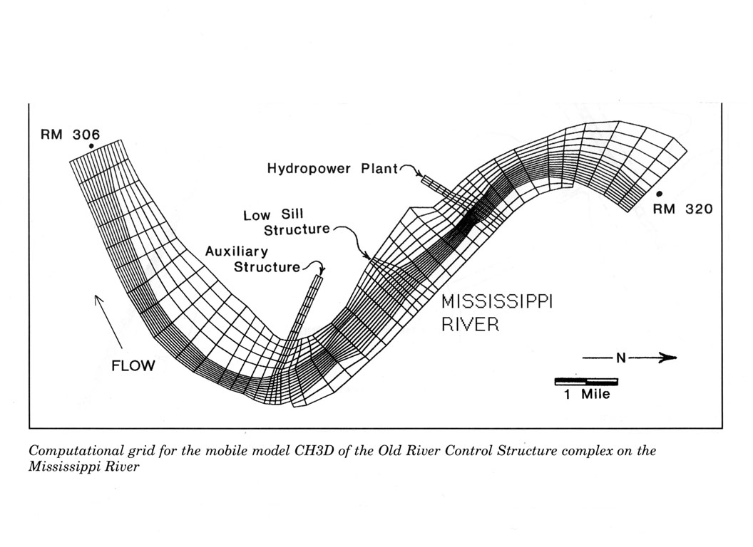

Figure 16. Modeling Nature & Technology: ORCS complex at Atchafalaya/Mississippi Rivers - USACOE Information Technology Lab

Under the River

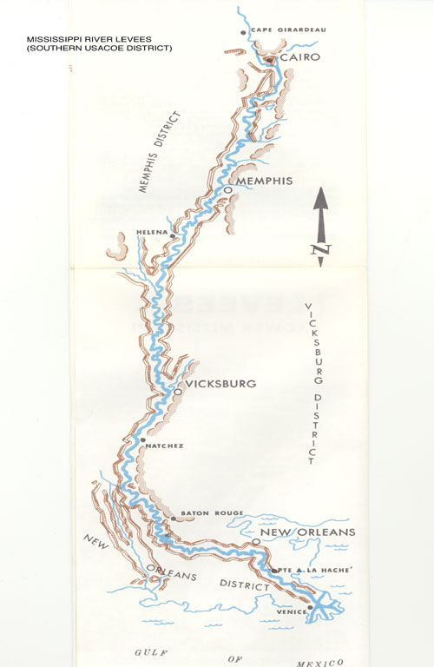

Figure 17. Mississippi River Levees - USACOE

The word flood, conceived negatively, is one of many attached to the natural environment which underscores the ambiguity between the mechanisms of nature and those of culture. Used to describe the river, it pertains less to a "natural" condition than to a human one - it is not the spread of water but the spread of humanity which creates the conditions for floods. Where waterscapes and civilizations have converged, people have often found themselves and/or their constructions flooded. If the Upper Mississippi has navigability as its primary theme, the Lower Mississippi's theme is flood control.

As the distinctions between modern culture's needs and its desires conflate, commercial demands (the production and expedient transportation of goods - agriculture, natural resource and related industries) have surged on the now well-navigable river. Flooding simply cannot be tolerated within such an economy. Although the river is substantially wider on the Lower Mississippi, the problem of controlling the volume of water is compounded by the inflow of the Ohio River at Cairo, Illinois. At this point, the Lower Mississippi's water volume more than doubles and streams with ever increasing pressure southward. Rather than engaging the riverside with constructions (whether in the form of major commercial cities or agricultural tracts) capable of absorbing the river's normal but threatening processes, civilization has traditionally maintained a defensive posture - enforced by The US Army Corps of Engineers.

Since the early 1800's beginning in New Orleans, a system of levees and floodwalls, covering over 3000 miles has been appended to the banks of the river. Incorporating roads and railways and framing recreation areas and farmlands, these earthen and concrete walls create a curious topography. Acting both as secondary riverbanks and fortress walls, the levees are theoretically surmounted or crevassed only by the USACOE "Project Flood" - a hypothetical every 500-year deluge.

Yet, historically, the levees have provided a tenuous security and their failures have often been disastrous. While preventing the damage of small floods, many of the levees have actually created the conditions for floods of major proportions. The river's increased pressure and volumetric confinement have caused it to rise more rapidly and furiously during floods. In the aftermath, the usual response has been the construction of higher and stronger levees further increasing the capacity of the river. It is a dangerous cycle, which may have been only mildly demonstrated in the summer of 1993.

A more recent response to the pressures of the river has been the construction of spillways. Artificial canals, controlled by mechanical floodgates, sluice water away from the river and send it into remote waterways, wetlands, and lakes. In addition, huge tracts of farmland, formally designated as floodways, are sacrificed to flood waters during emergencies by surrounding the land with secondary levees. Through floodgates or fuseplug levees (as well as levees intentionally designated for explosives), water is diverted into these areas and then, as in the case of the New Madrid Floodway, allowed to return to the Mississippi at its downstream end.

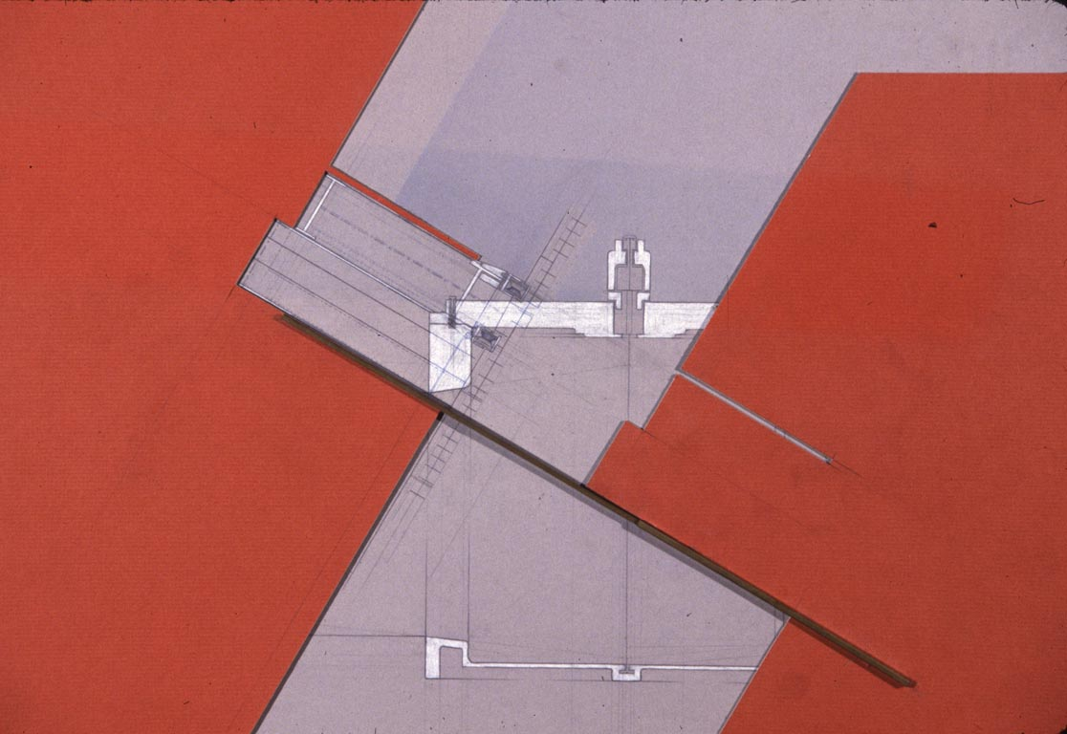

Figure 18. Levee fuse plug study, New Madrid, La.: large areas of farmland are designated as floodways. Border levees, breached by both mechanical and incendiary "relief valves", allow floodwaters to enter (and, inevitably, destroy) these tenuous agricultural tracts during crisis flood stages. (Phase 1 -Christiano Bottino)

There is another consequence resulting from flood control that is less visible. "Shackled" by the levees and floodwalls, the river cannot move laterally to drop its sediments into backwaters or filtrate through the now isolated and shrinking wetlands. While making these vital ecological areas available to agriculture and other forms of production (considered a boon), the levees and river control structures impede the natural river processes of irrigation and sedimentation in the Mississippi basin. The land loses its capacity to absorb water, causing rains to skim off the landscape in flood sheets. In the delta, the situation has become critical. There, the desiccated land is shrinking even as dumped sediment expands the delta into the Gulf of Mexico. Much of New Orleans is 12 feet below sea level and still sinking. Furthermore, saltwater has begun to back up from the gulf into the land where fresh water saturation used to resist the pressure of the sea. Agricultural land is threatened as are the aquifers supplying drinking water to rural communities and cities. The solution? Flooding.

In perhaps a fitting recognition of the symbiotic development between instrumental mechanics and nature, a new branch of "ecological engineers" within the USACOE has quietly developed a program of controlled flooding. In conjunction with valve devices called Freshwater Diversion Structures, spillways designed for flood relief have been adapted to siphon river water and return it back into the Louisiana landscape.

Finally, in the past few years, the USACOE and the US Government has begun to reconsider its overall policy regarding flood control. For the first time in two centuries, a strategy of retreat is being tested. In order to "restore the river's natural systems", private landowners and municipalities in the Mississippi flood plain are being compensated by the government for abandoning their land. Either by relocating to higher ground or merging with other further removed communities, entire towns are considering returning the ground on which they presently stand back to the river.

Resistance to this idea is great; the cultural economy is too much in motion and has difficulty reconciling the fundamental ideal of Progress with a "backward" movement - even for the ideal of Nature. While proponents of the move argue for the preservation of vital ecological systems either as a matter of global survivability or spiritual resuscitation, others, particularly those who are directly affected, feel that a return to a simpler form of the "natural " river is unacceptable because of the potential loss of economic gain and the creature comforts it has produced.

But there is another point of view that, even as it endorses the move back from the river's edge, is also troubled. It is concerned that a return not only idealizes the form of the river, but also further dislocates humanity by delimiting the earth into "natural" (river) and "unnatural" (civilization) territory. Above all, it is concerned that a return represents a futile aspiration that does not acknowledge the facts of evolutionary - as opposed to "progressive" - existence. Implicit in this view is a faith in technology's capacity to fix its mistakes; not out of instrumentalist greed but, rather because it believes that humanity is naturally bound, for better or worse, to its own creations.

This view is based upon a fatalistic epistemology. It believes that attempting to dismantle and forget the hard won products of incremental Knowledge, would be to dismantle ourselves. Yet, it is hopeful in bringing with it a remembrance of technology not as an instrument discovered "out there" and placed in the hands of humanity to wield, for better or worse, in the face of Nature, but as a natural human practice derived from the dynamic space of the earth - a space called Nature. It is this very space that the project of humanity must constantly negotiate in order to be what it is.

Student Proposals:

The Mississippi Studio began from the perspective that the many and difficult problems plaguing the Mississippi River are the result of a forgetfulness regarding Technology rather than its utilization. The resulting projects are preliminary and tentative. Concerned less with specific solutions than with ways of considering the problems, they aspire to something that is not only difficult to represent but difficult to even think given the power of assimilated cultural conventions. Virtually, all of the projects involved a public and/or civic dimension. This tendency was directed less toward the provision of social amenities than the making of a didactic space where a shared comprehension of life along the River might be more fully attained. Derived from a study of the relationships between "found" nature and "constructed" nature and a process of interpreting and representing the coincidence of natural and technological tectonics along the Mississippi, they attempt to demonstrate a more synthetic conception of the river and its future. Rather than proposing object/mechanisms of resistance or subordination, these are projects of accommodation and/or compliance with the mechanisms of the Mississippi's system. They are less examples of fixed forms than descriptions of states in a non-hierarchical systematic interaction between the artifice of humanity and the surface of the earth.

Project 1: Community Facility, Arsenal Island, Iowa-Illinois (Hideyuki Chiba)

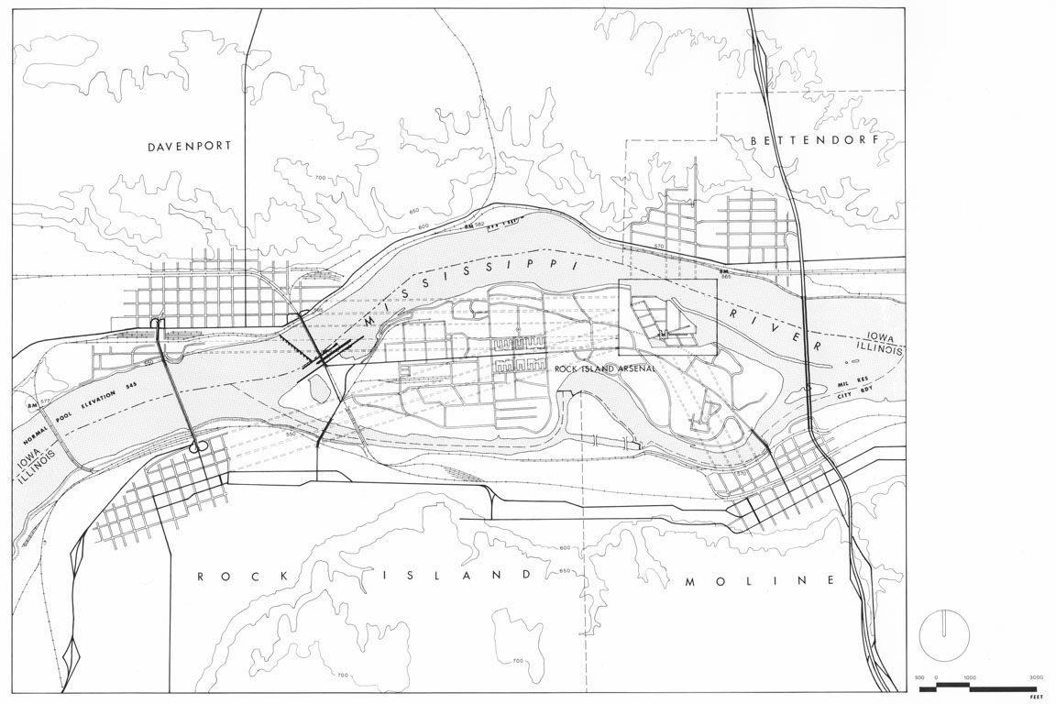

Figures 19: Site plan of Arsenal Island: Community Center in NE corner. Community Facility, Quad Cities

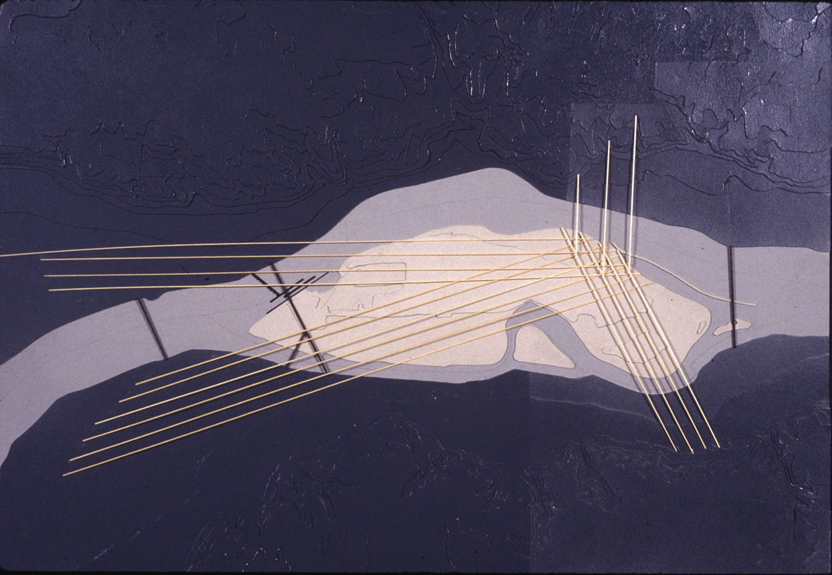

Figure 20: Site line map indicating views to the site along respective street grids of the four cities. Community Facility, Quad Cities

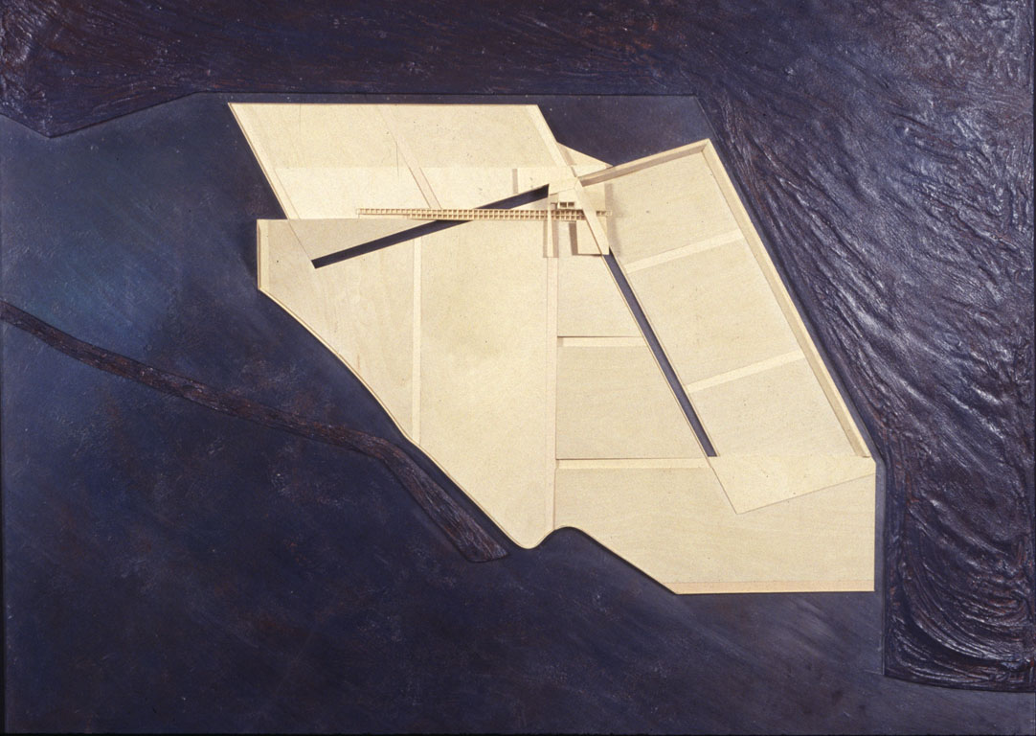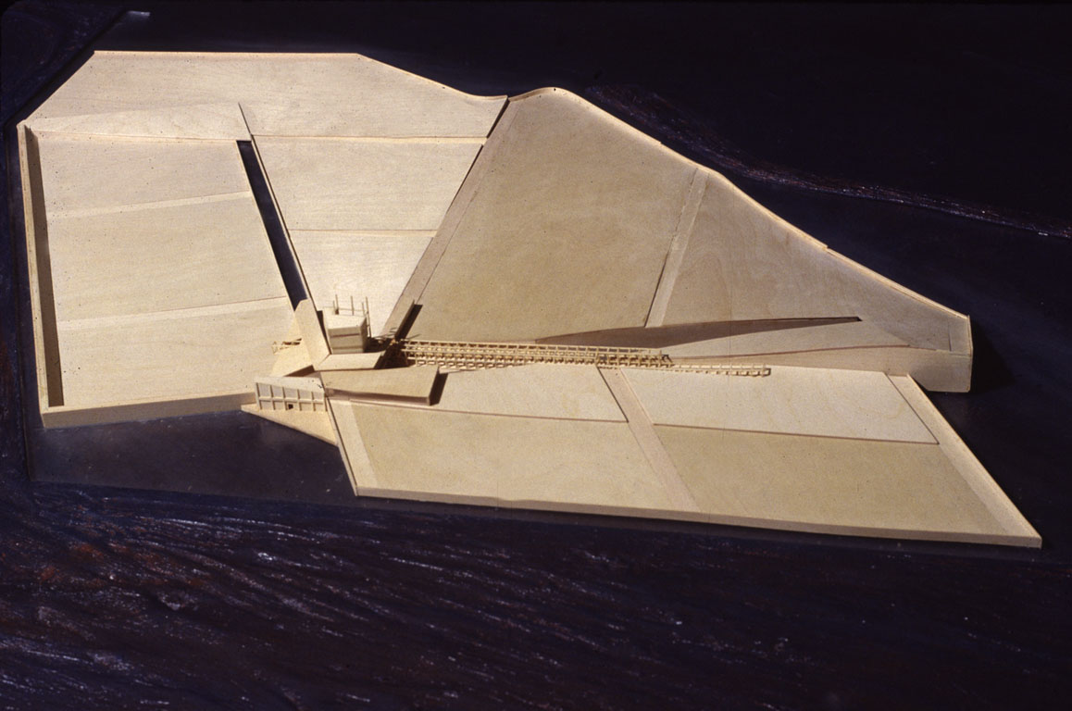

Figure 21a/b: Model: four topographies and river edge conditions hinged by shared community facility. Community Facility, Quad Cities

The Quad Cities of Davenport and Bettendorf, Iowa and Rock Island and Moline, Illinois cohere a site which, perhaps better than any other, demonstrates the conflicted responses to the Mississippi's flood waters (See figure 19). Although the communities are united for commercial purpose, their flood policies underscore an uneasy alliance forged more on proximity than mutual interest.

With its historic Main street and quaint water front, Davenport promotes itself as a "river town" and has consistently voted down the installation of the traditional view obscuring levee system like their counterpart across the way at Rock Island. During the Flood of '93, citizens of Davenport watched helplessly as the levees of Rock Island shunted water across the river to their unprotected town.

Like Rock Island, Moline and Bettendorf also survived the flood, albeit with very different strategies. In a move away from the river, Moline had previously relocated its' commercial zones to higher ground, leaving the river edge largely to its own processes. On the other hand, Bettendorf took a more technological approach, investing in a "folding levee" system - a three part wall which hinges into place according to water levels - at low water, the river view is unimpeded; at flood level, the town is fully protected.

Arsenal Island sits in the middle of the channel between the Quad Cities. A proposed community facility and land/waterscape is sited on the only portion of the island which surveys and is surveyed by all four towns (see figure 20). The design was generated by the urban topography (natural and constructed) of the towns and becomes a shared terrain. This new surface of land and water enact the fractious history of the four town's relationship to the river and to one another, forming the locus for reconciliation (see figure 21a,b).

Project 2: Flood Park, New Boston & Keithsburg, Illinois (James Wong)

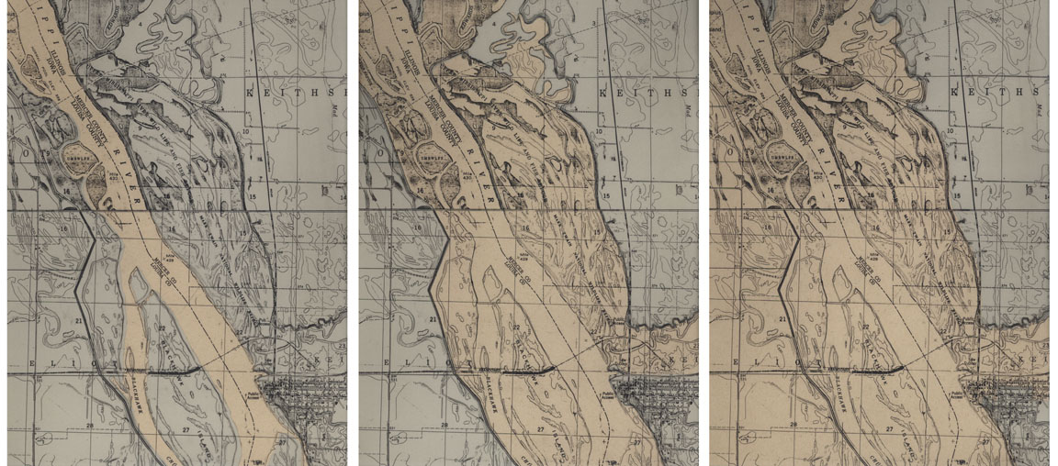

Figure 22a/b/c: Site map of New Boston & Keithsburg showing extent of mid-stage flooding encircling Keithsburg. Flood Park, Keithsburg, Ill

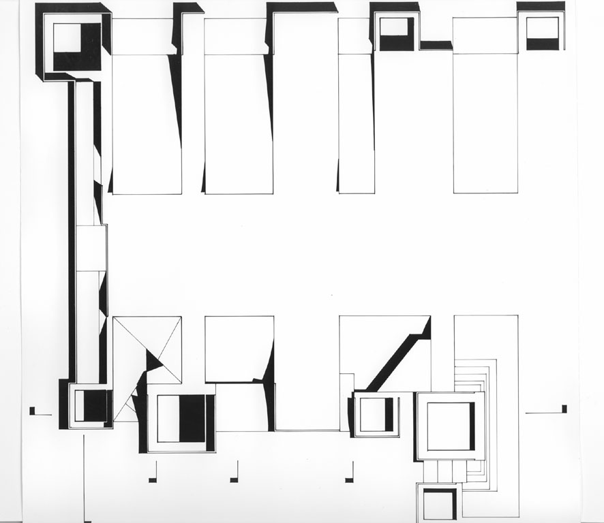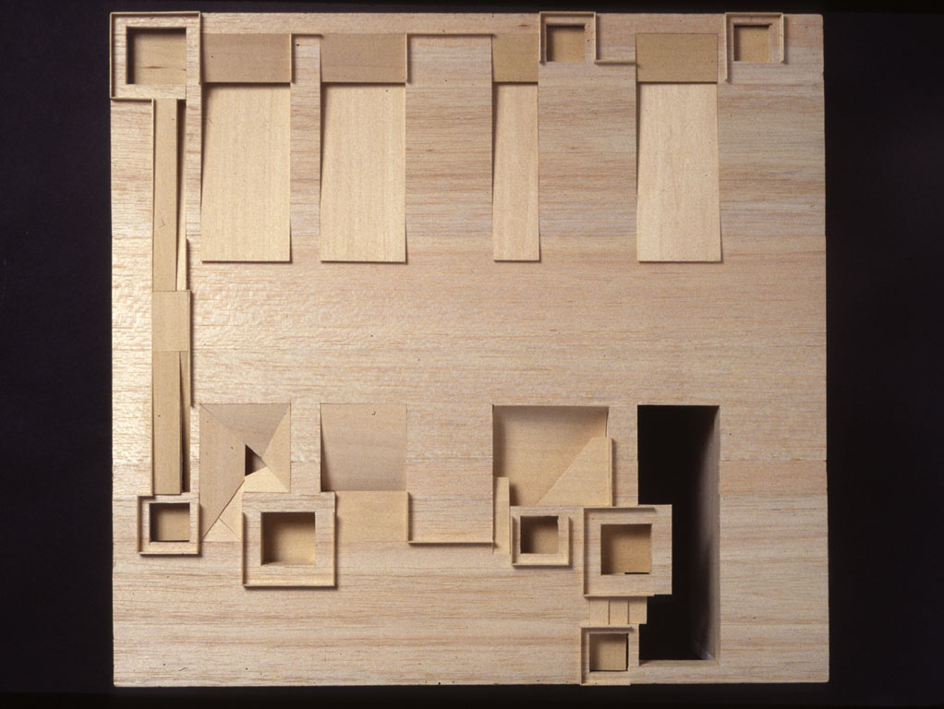

Figure 23a/b: Park Plan/Model indicating traces of former house foundations and varied water drainage systems. Flood Park, Keithsburg, Ill

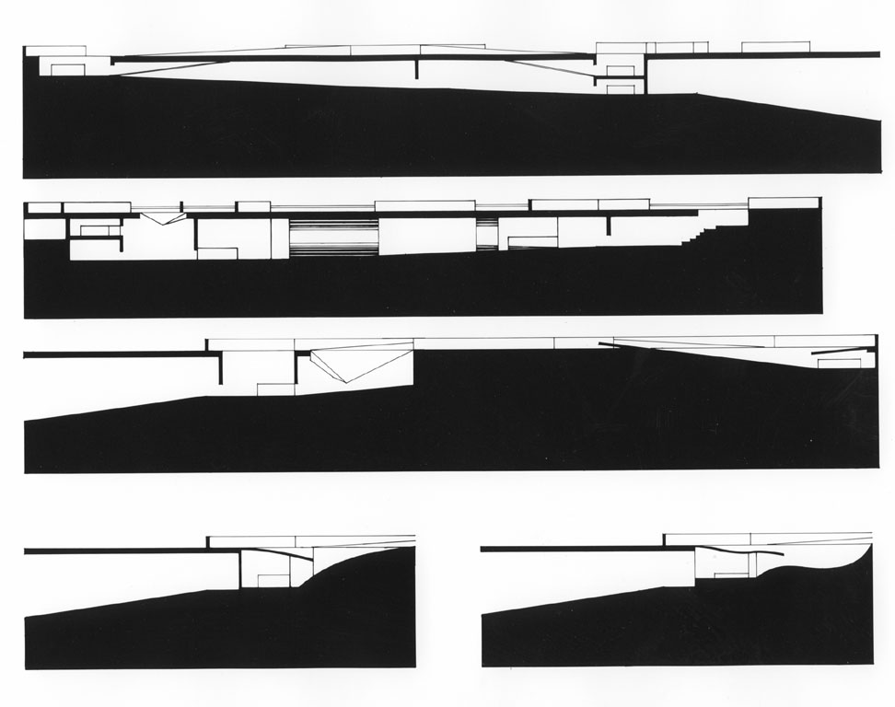

Figure 24: Sections through Park and drainage structures. Flood Park, Keithsburg, Ill

Two neighboring farming towns located within a landscape of river bluffs have sited themselves according to their commercial need for accessibility to the river. The older community of New Boston sits on top of the bluff, sacrificing accessibility for safety. Keithsburg was built on lower ground and used the bluff as a protective wall in conjunction w/ a levee system which begins at the bluff and encloses the town within a U-shaped embankment (see figure 22).

The huge horizontal spread of floodwater in relation to its minimal rise underscores the low topography of the area. In 1993, while New Boston remained unaffected, floodwaters swept around Keithsburg's levees and entered the town, uncontested, from behind. Ironically, as floodwaters began to recede, the Keithsburg levees blocked the return, forming a lake within the town which permanently destroyed a large residential neighborhood (aided by new Federal legislation, residents have since abandoned the area and moved to higher ground on top of the bluff).

Using a trace of the abandoned grid of neighborhood streets, lots, and house foundations, a proposal for a "flood valve park" acts both as a memorial and distribution system for the town (see figure 23). Excavations at the sites provide an interconnected network of spaces for community activity and the restoration of localized backwater ecologies within a flood relief system that drains the site of both rainwater and future flood waters (see figure 24).

Project 3: Perpendicular Park, Helena, Arkansas (Beth Pappas)

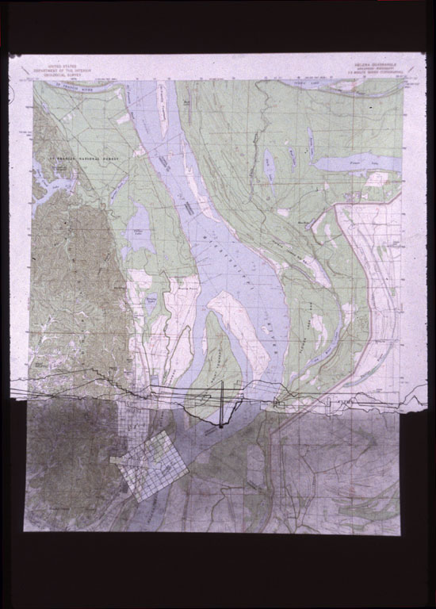

Figure 25: USGS map showing plan and topographical section through park, Perpendicular Park, Helena Ark.

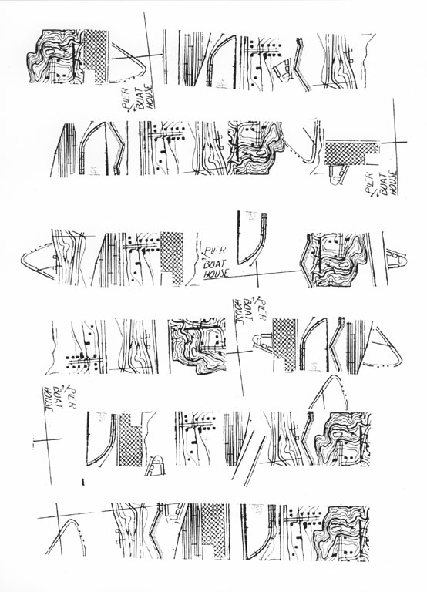

Figure 26: Transect cuts through Helena indicating USGS conventions for "natural" and "infrastructural" entities. Perpendicular Park, Helena Ark.

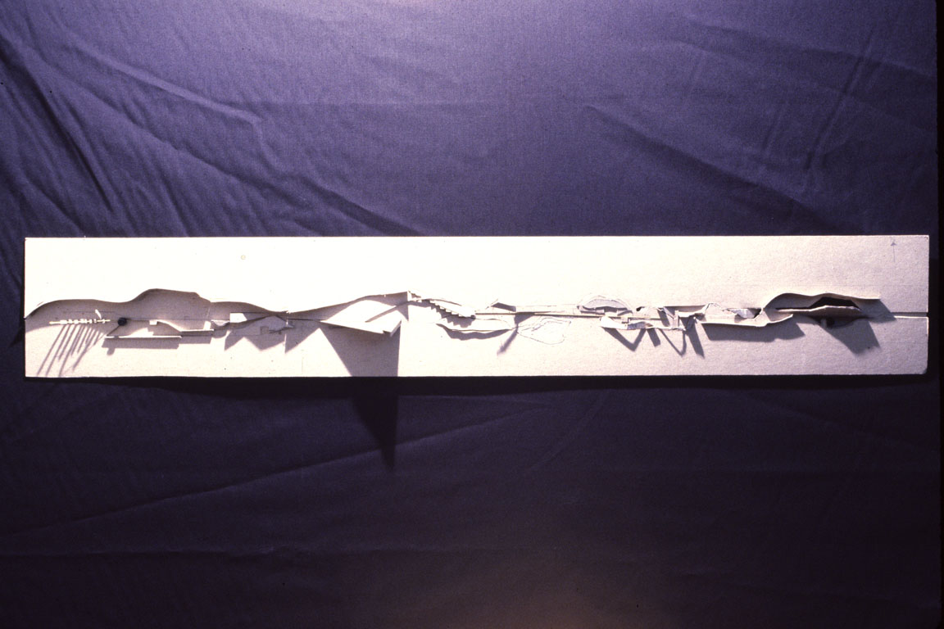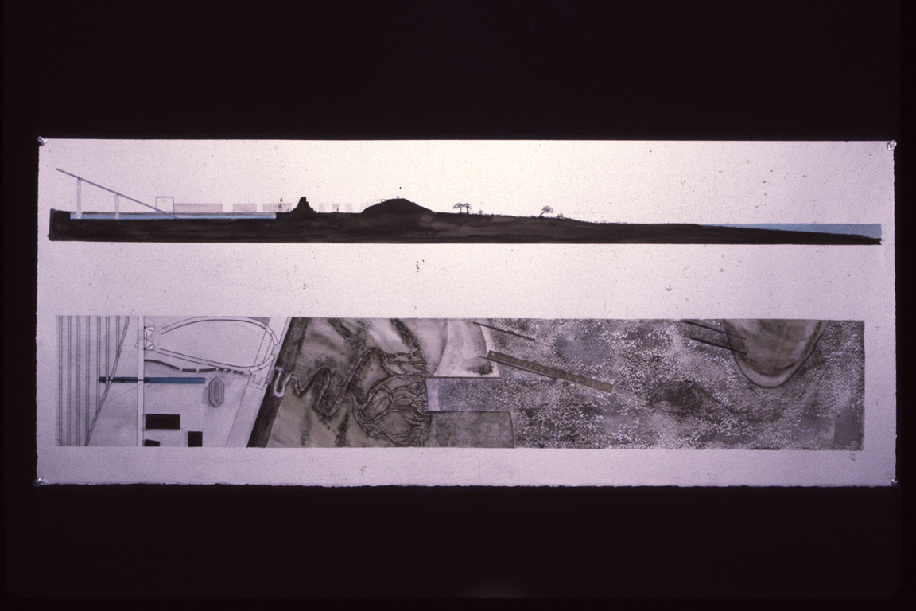

Figure 27a/b: Model of proposed topographical section through park landscape and artifacts. Plan of proposed Perpendicular Park, Helena Ark.

Helena represents a prototypical commercial community whose life is inextricably bound to the river. Using the strategy of the transect common to field biologists when mapping the effects of disruption to local ecologies (e.g., oil spills, floods, etc.), a gridline was cut (perpendicular to the river) through a USGS plan of Helena along which its diverse forms are represented according to conventional mapping technique (see figure 25). The strata of mountain topography, street grids, fields, railroads, power lines, swales, buildings, wood land, levees, estuaries, conveyors, water, piers, islands, etc. describe a baseline transect whose elements when reordered in virtually any conceivable sequence would describe an actual transect configuration somewhere else along the full length of the Mississippi River (see figure 26).

Reinterpreting the land, water and built forms of Helena along a linear park cut through the foothills, through the city to the river , this proposal reconsiders and relocates the program of the Environmental Demonstration Center located within the Lock and Dam Complex in Alton, Illinois. Rather than emphasizing the "compatibility" of juxtaposed systems characteristic of the former site (which maintains the dichotomy of the natural and technological), this new eco-scape in Helena stresses their integration and mutual constitution (see figure 27 a, b).

Project 4: Alexander Technique Research Facility, Spokane, Louisiana (Ali Koluman)

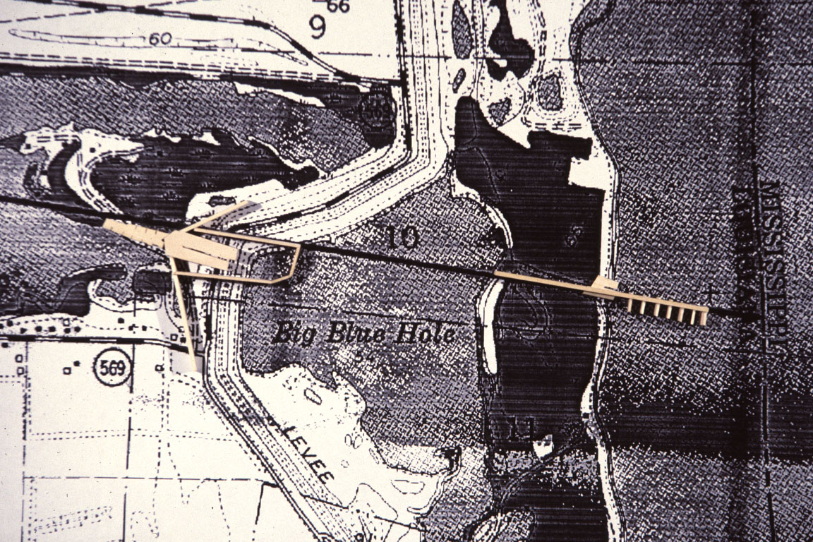

Figure 28: Site plan , showing edge of Lake St. John, Levee, Big Blue Hole and river edge. ARTF, Spokane, La.

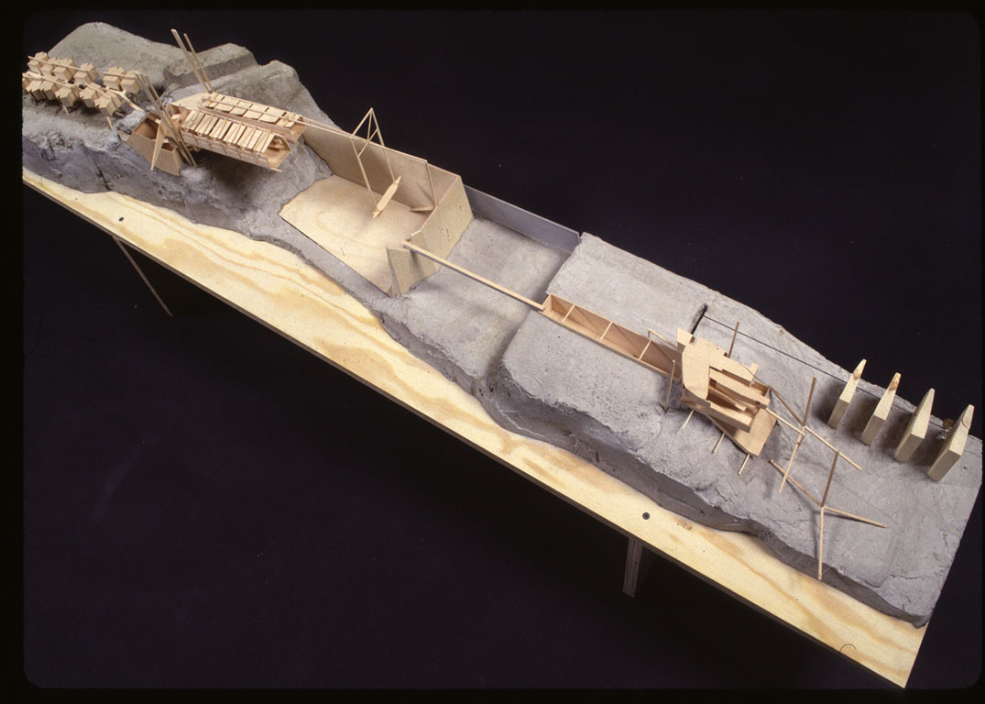

Figure 29: Model (pump wheel set in river diverter structure). ARTF, Spokane, La.

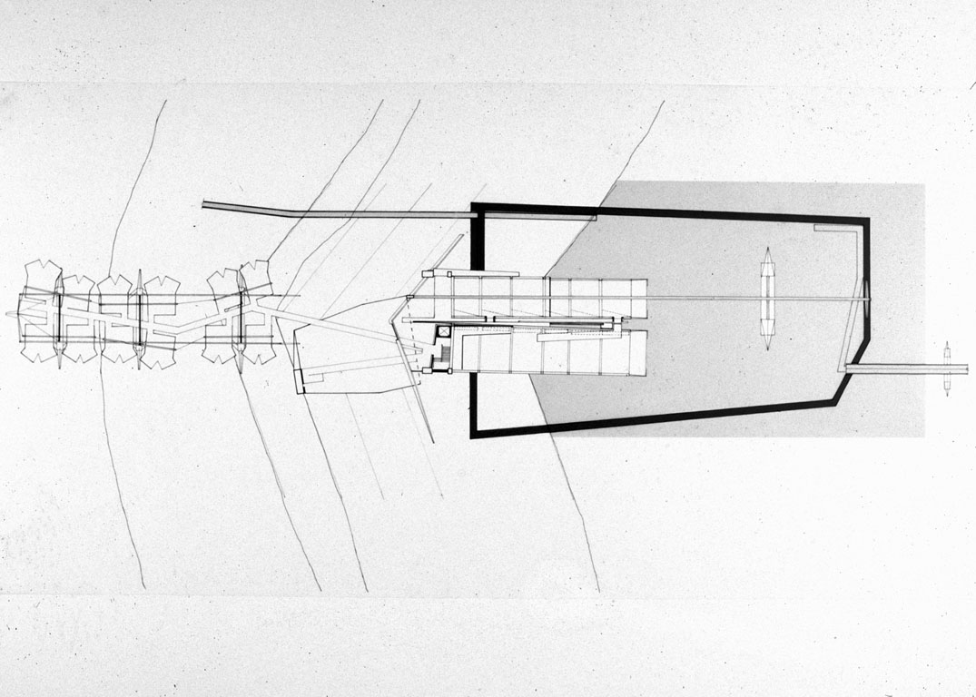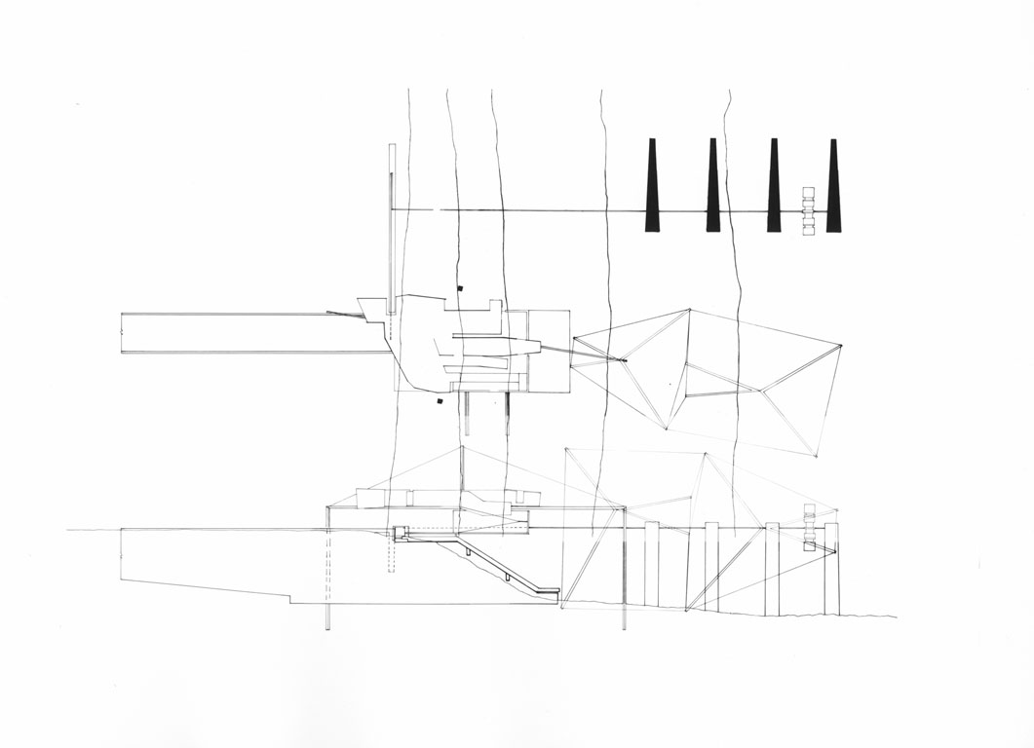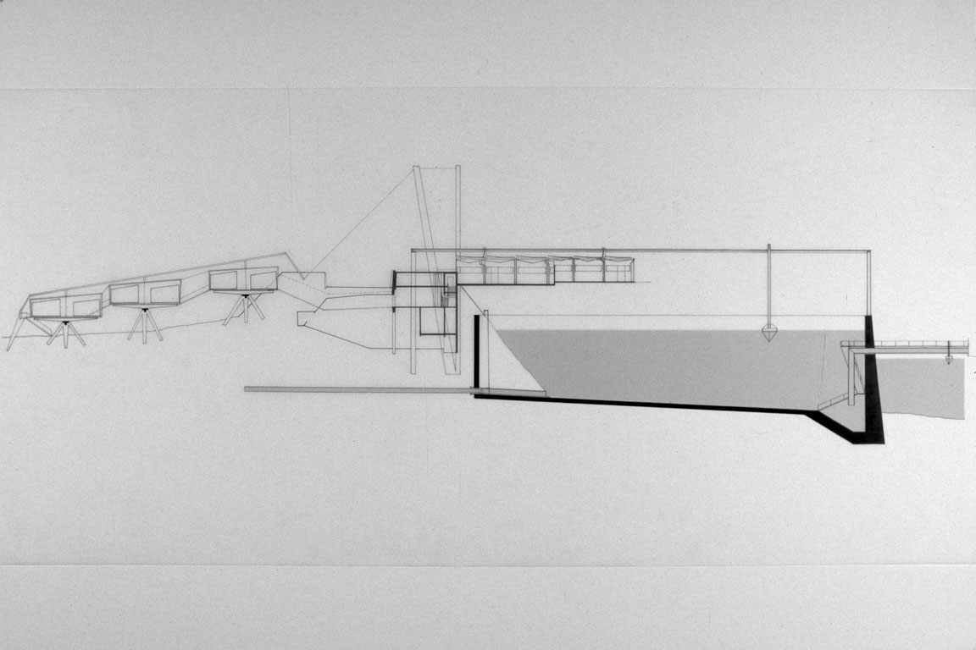

Figure 30a/b/c: Plans at research & diverter structure/Section at Levee and edge of Big Blue Hole. ARTF, Spokane, La.

The Lower Mississippi is flanked by numerous oxbow lakes. These "old river" lakes are the traces of river meanders "cut off" from the body of the Mississippi either by the natural process of erosion or by intentional excavation for navigational ease.

A research facility for the Alexander Technique is proposed at one such oxbow, Lake St. John (see figure 28). Connecting the lake to the river, the facility straddles a levee that separates the lake from both the river and a "blue hole" - an autonomous pool of deep water on the river side of the levee created by leakage from the lake. From a hydrological point of view, blue holes represent an ox-bow lake's attempt to return to the body of the river.

The Alexander Technique, familiar primarily to dramatic actors, is a theory of body positioning and extension which restores the "natural" equilibrium of the human body lost through acculturated habit. The research facility is constructed on the model of Buckminster Fuller's Tensegrity Mast and proposes a structure similar to the human spine acting in tension rather than compression (see figure 29). Operating as a restorative link between the river and its former condition., the Facility's pump/waterwheel drives the recombination of Lake and River water at a constrained edge of the blue hole. Suspended laboratory and dwelling pods then respond to the hydrology, extending away from or toward the communal auditorium constructed within the levee (see figure 30).

Project 5: Cairo Civic Center, Cairo, Illinois (Cristiano Bottino)

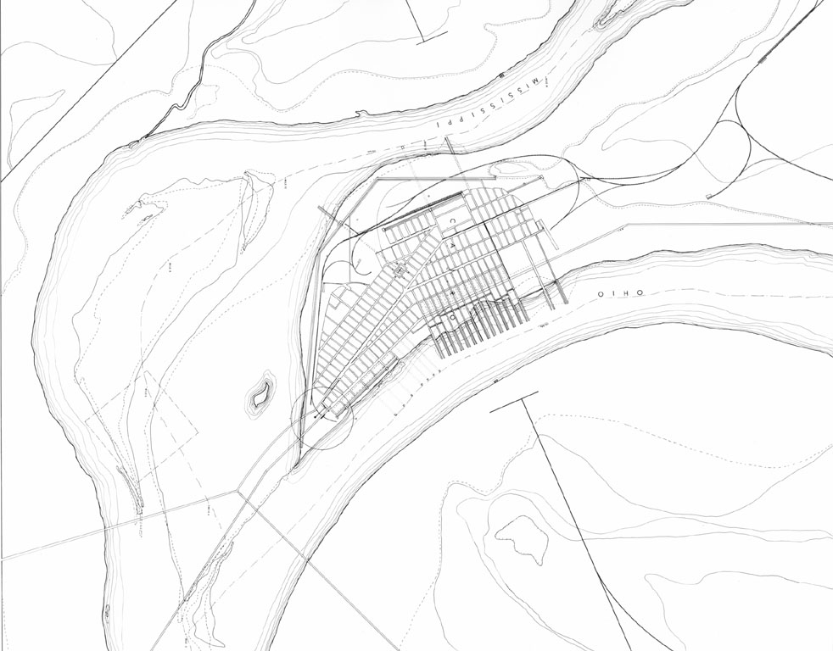

Figure 31: Site Plan: Cairo Civic Center, Cairo, Ill.

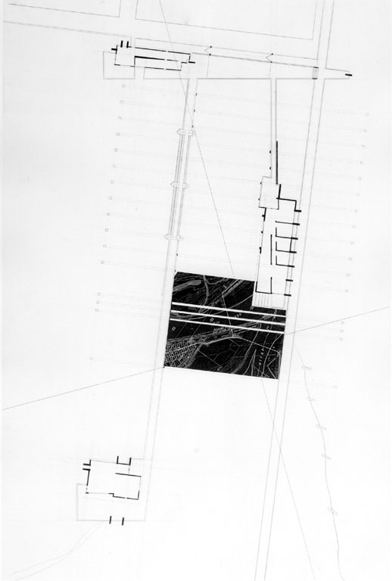

Figure 32: Plan at Civic Center/Town Hall, Cairo Civic Center. Cairo, Ill

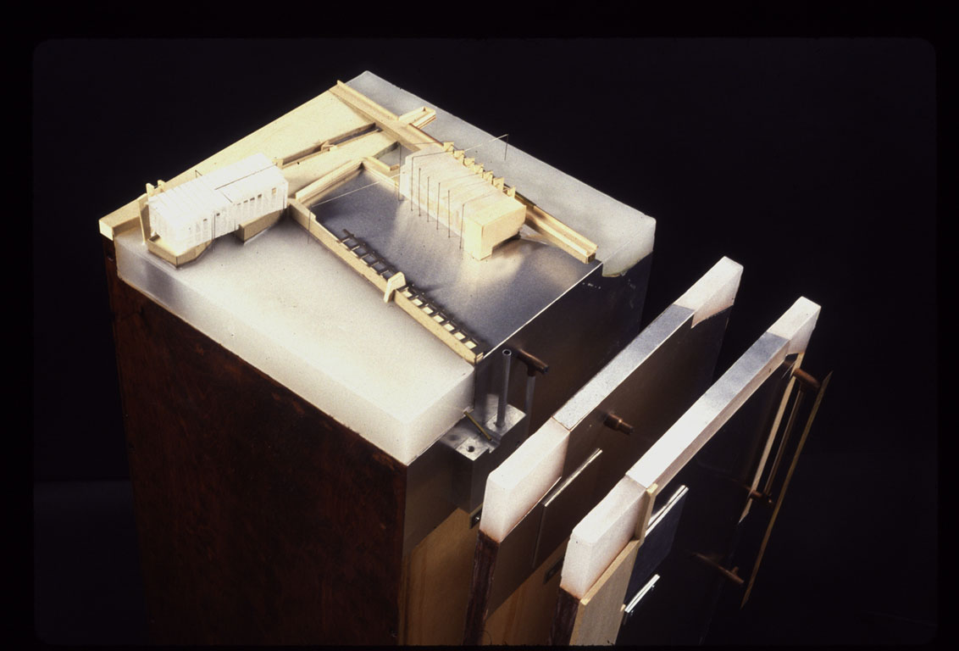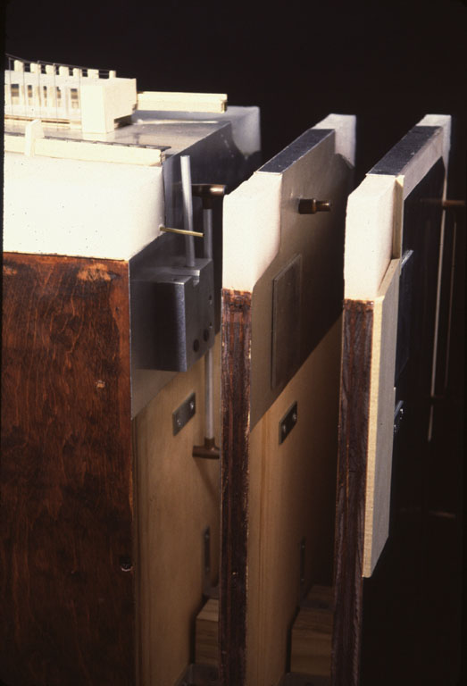

Figure 33a/b: Model & Detail at Civic Center/Town Hall, Cairo Civic Center, Cairo, Ill.

One of the oldest settlements in Illinois, the city of Cairo lies at the USACOE's regulatory point of division between the Upper Mississippi and the Lower Mississippi. Due to the confluence of the Ohio River which empties the bulk of eastern continental waters into the Mississippi, the river dramatically changes in dimension and character. While keeping navigation water levels up is typically necessary on the upper river, holding water levels down is necessary on the lower.

For over a century, Cairo operated as a major railroad hub for the transfer of resources to and from the river. Yet as tow barge and trucking systems developed and swelled, the hub became obsolete and an obstruction to river traffic. Today, the city is surrounded by abandoned rails and conveyors along the river and besieged by ground water problems as the rivers reach under and erode the peninsula on which it stands. Fighting to forestall its impending demise, the city council is trying to promote Cairo as a tourist attraction .

This proposal (see figure 31, 32) utilizes the traces of Cairo's dying infrastructure to site a new town hall and chamber of commerce, linking its historic park at the tip of the peninsula to the old city. The building structures are tethered to shore as well as to a renovated roadway connected to the park; yet they also float on the rivers' back waters. Elaborating on the directives of a small USACOE manual on "flood prevention construction," (see figure 33 a, b) the buildings' elements are intentionally displaced by the interactivity of the two rivers and the land forming a variety of alternating interior and exterior configurations (see figure 8).

Carl Mitcham's book, Thinking through Technology, The path between engineering and philosophy (The U. of Chicago Press, 1994) provides a very useful overview of various conceptions of "technology."
e.g., William Cronon, Donald Worster, J. Nicholas Entrikin, Donna Haraway, J.Baird Callicott, Kenneth Olwig, Carolyn Merchant, among others.
The question of why (or from where) a student has chosen a particular detail, form or space-shape is a common one in the design studio/review. While I generally feel this is a dangerous and misleading question (directed exclusively to the rhetorically unpersuasive projects), it does imply the importance of a "logical" coherence or consistency throughout the process of design. By studying/modeling the actual detailed tectonics of material, structure, configuration, etc. of the general conditions being researched (say, revetments in the Lower Mississippi) and correlating them to specific effects produced (artificial shorelines made to appear natural, shunting of currents creating increased water speeds and volume, etc.), much was gained toward an understanding of how certain formal configurations derived from the River itself (rather than from either Plato or Derrida) might achieve intended effects in the student's subsequent design proposals.
Mark Twain, Life on the Mississippi, 1883
The steps toward a virtual river had previously been taken with the construction of a scale model of the river built on a few acres in Clinton, MS, (see figure 4). See Bruno Latour, Science in Action (Cambridge, Ma; Harvard University Press, 1987, ps 230-232) for a relevant commentary on the Delft Hydraulics Lab in Holland in regard to virtualism and re-scaling technological control.
Forced to release water from swollen tributary dams, The Army Corps of Engineers infuriated the downstream citizens of Iowa helplessly watching the floodwater swell into their homes. In southern Illinois, citizens fearful of losing the historic town of Prairie du Rocher, blew up levees upstream against the advice of the USACOE in hopes of relieving flood water pressure. Their tactics worked.
Much could be said about the relationship of the military to the landscape; it is an old and intertwined one and has been taken up by J.B.Jackson and others who have noted how we have come to see landscape largely through military strategies of mapping, defensive sitings, reconnaissance, offensive maneuvers, etc.
It has been suggested that the use of the upper case in (N)ature and (T)echnology in the following text contradicts the thesis of this paper by underscoring their polarity; however, my intention is to maintain a focus on the iconic status which culture has conferred on these concepts.
The constructive function of language in this sense recalls both the later Wittgenstein's "language games" in Philosophical Investigations and Heidegger's distinctions between "earth" and "world" in The Origin of the Work of Art.
The constancy of world views in other cultures, while useful as illustrations of ways of relating to the earth, is perhaps most interesting in terms of the enduring aspect of certain myths and metaphorizations used to describe this relationship.
For a further discussion of these conceptions, see Joseph R. Des Jardins, Environmental Ethics (Belmont, Ca., Wadsworth Publishing Co. , 1993)
See Uncommon Ground: Toward Reinventing Nature, ed. William Cronon (New York, W.W. Norton, 1995) for a number of essays on the various incarnations of Wilderness.
See Carolyn Merchant, The Death of Nature (San Francisco, HarperCollins, 1980) for the seminal discussion on nature during the Scientific Revolution and Enlightenment.
The strategic use of language descriptions in the "administration" of landscapes has been noted in an essay by Carol Burns, "On Site" in Drawing Building Text, ed. A. Khan (New York, NY, Princeton Architectural Press, 1991)
The Transcendentalists, in turn, can be traced back through the Romantics and Rousseau to the classical, pastoral tradition of Theocritus and Virgil's Eclogues. In this tradition, the" natural" acquires the ethical status of the "good." For an excellent discussion of the relationship of American culture to the European pastoral tradition, particularly in its' confrontation with industrialization, see Leo Marx , The Machine in the Garden (Oxford University Press, 1964).
At the level of conventional politics, this view configures the distinction between the environmental policies of Preservationists such as Clinton's Interior Secretary, Bruce Babbitt, who see Nature as a spiritual resource with independent standing as opposed to Conservationists such as Reagan's Interior Secretary, James Watt, who see it as a managed resource in the service of a cultural economy (conserved for commercial, recreational, or whatever productive value it might yield).
Joseph R. Des Jardins, Environmental Ethics (Belmont, Ca. Wadsworth Publishing Co., 1993, P.175)
Richard Rorty,"Freud and Moral Reflection" in Essays on Heidegger and Others, Philosophical Papers Vol.2 (Cambridge, England, Cambridge University Press, 1991). Stephen Jay Gould has expanded on this theme in his new book Full House (New York, Harmony Books, 1996), discussing the continuing subtle cultural resistance to paleontology's discovery of "deep time" and its' refutation of the Biblical story that the history of the biotic earth and human life are co-extensive.
ibid.,144
Martin Heidegger, The Question Concerning Technology and Other Essays (New York, Harper & Row, 1977), p. 14.
While drawing a controversial distinction between modern and pre-modern technology, Heidegger's discussion of the Greek term techne attempts to support this argument as well as to track the evolution in metaphysics of technology and science in relationship to instrumentality and "instruments."
Martin Heidegger, Being and Time, trans. Robinson and Macquarrie (New York, Harper & Row, 1962) p.95
Don Ihde, Instrumental Realism, The Interface between Philosophy of Science and Philosophy of Technology, (Indiana University Press, Bloomington, In, 1991) p. 53. A leading philosopher of technology, Ihde provides a useful discussion of Heidegger, Foucault and T.S. Kuhn in regard to the role of technological instrumentation in their thinking, particularly as it relates to the "embodied" praxis-perception model developed from existential phenomenology.
Despite these developments, change in thinking is slow. Most normative descriptions of the biota remain lodged in the analytic/scientific language which both separates itself from ( by considering itself objective) and transforms Nature (by re-describing it). In this regard, the classificatory work of the 18th century naturalist, Carolus Linnaeus who is largely responsible for the categorization and reductive arrangement of the elements of Natural Science followed the lead of the physical sciences.
J. Baird Callicott," The Conceptual Foundations of the Land Ethic" in In Defense of the Land Ethic (Albany, NY: Suny Press, 1989), 87
For a general account of the changing language of science see Bruce Gregory's Inventing Reality, Physics as Language (John Wiley & Sons, New York, 1990)
Paul Virilio, The Lost Dimension, (New York, NY, Semiotext(e), 1991) p. 111. Both Don Ihde, in Instrumental Realism, and Virilio use Mandelbrot's computer work in fractal geometries to underscore their points about technologically mediated perception as related to the natural world. However, while Ihde goes only so far as to suggest the possibility of " a role for such mathematics in relation to natural phenomena", Virilio's interest is in an entirely "new perception of space."
Sanford Kwinter, "Landscapes of Change: Boccioni's Stati d'animo as a General Theory of Models" in Assemblage 19 (Cambridge, Ma.: MIT Press, 1993), 58-59
Ibid. ,59

